Chapter 1

Introduction

1.1 Background of the Study

Suicide is one of the most critical and under-addressed public health challenges in low- and middle-income countries (LMICs). Bangladesh, a densely populated South Asian nation, is no exception. Estimates suggest that the country witnesses approximately 10,000 suicide deaths annually, though the true figure is likely far greater due to widespread social stigma, cultural barriers, and the near-total absence of a systematic national suicide surveillance registry [12, 13]. Unlike high-income countries that maintain structured reporting mechanisms, suicide data in Bangladesh is predominantly captured through fragmented sources — newspaper reports, police records, and hospital admissions — each with their own inconsistencies and biases.
Among these sources, newspaper-reported data represents the richest and most accessible public record of suicide incidents in Bangladesh. Several researchers have relied on this source to understand patterns related to method, demographics, location, and motivating factors [2, 3]. However, the critical limitation of such datasets lies in their inherent incompleteness. Demographic details such as age, socioeconomic status, and occupation are frequently missing, while spatiotemporal and environmental attributes — latitude, longitude, weather conditions — are almost never directly recorded. The resulting missingness rates often exceed 50–90% for many important features, rendering conventional statistical and machine learning analyses unreliable or outright infeasible [14, 15].
This structural data gap creates a significant barrier for researchers and policymakers who wish to identify high-risk demographic groups, understand the environmental and social triggers of suicide, and design targeted prevention programmes. Addressing it requires a methodologically rigorous, reproducible pipeline that can handle severe missingness, preserve meaningful patterns, and ultimately surface actionable insights from incomplete real-world data.

1.2 Problem Statement

The absence of an official, structured suicide surveillance system in Bangladesh forces researchers to rely exclusively on media-reported cases. While such datasets are valuable as the primary available source, they are characterised by extreme and non-random missingness — often exceeding 50–90% for critical features such as socioeconomic indicators, geographic coordinates, and weather-related variables. Standard machine learning approaches applied directly to such incomplete data either fail entirely or produce heavily biased results [14, 15].
Beyond the missingness problem, there is no established methodological guideline on which imputation technique performs best when combined with which clustering algorithm for this specific domain. In the absence of any ground-truth labels or external benchmarks, it is also unclear how to fairly evaluate and compare multiple unsupervised learning solutions — especially when cluster size imbalance and excessive noise make traditional validation metrics misleading [16].
Consequently, hidden patterns and risk profiles within existing newspaper-based suicide records remain undetected, directly hindering evidence-based suicide prevention efforts in Bangladesh.

1.3 Research Motivation

The primary motivation of this study is to bridge the gap between highly incomplete real-world suicide data and meaningful, interpretable pattern discovery. The research is driven by three interconnected observations:
First, Bangladesh lacks any algorithmic, data-driven analysis of its suicide landscape at scale. Existing studies have largely relied on manual grouping or simple statistical summaries, leaving a significant methodological void [2, 3].
Second, the international literature on missing data imputation and unsupervised clustering — while extensive — has rarely been applied systematically to social and public health datasets from South Asia characterised by this level of missingness and mixed data types [16, 17]. Existing benchmarks focus predominantly on clinical or genomic data, and no published work has applied a comprehensive, multi-method imputation–clustering pipeline to a large newspaper-derived social dataset from Bangladesh.
Third, standard clustering validation metrics are known to be misleading when clusters are severely imbalanced or when algorithms such as DBSCAN assign the majority of points as noise. A fairer, more interpretable evaluation framework is therefore needed for this application domain.
“Which combination of missing-data handling and unsupervised learning techniques produces the most reliable, interpretable, and actionable clusters from newspaper-based suicide records in Bangladesh?”

1.4 Research Objectives

The specific objectives of this research are:
- To expand and enrich an existing publicly available dataset of 760 newspaper-reported suicide cases in Bangladesh (covering the year 2020) by manually collecting 857 additional cases spanning 2017–2025, and by introducing 9 new socioeconomic and clinical attributes, yielding a final dataset of 1,617 records and 34 analytical columns.
- To perform exhaustive data cleaning, standardisation, and conditional filling of missing values using external geocoding (Geopy) and meteorological (Meteostat) APIs, substantially reducing missingness in spatial and weather-related features prior to any imputation.
- To implement and systematically compare three state-of-the-art imputation methods — Multiple Imputation by Chained Equations (MICE) [8], K-Nearest Neighbours (KNN) Imputation [9], and MissForest [10] — each applied under two predictor-selection strategies (correlation-based context-aware and all-available no-context), producing six fully imputed datasets.
- To apply four established clustering algorithms — K-Means [11], Agglomerative Clustering [12], DBSCAN [13], and Spectral Clustering [14] — across all eight datasets (six imputed and two non-imputed baselines), generating 32 complete imputation–clustering pipeline combinations.
- To evaluate all 32 pipeline combinations using five established internal clustering validity indices — Silhouette Score, Calinski–Harabasz Index, Davies–Bouldin Index, Dunn Index, and Xie–Beni Index — supplemented by a newly proposed balance metric designed to penalise cluster size imbalance and excessive noise, combined into a single composite ranking score.
- To identify the best-performing imputation–clustering combination and provide detailed interpretation of the resulting clusters across demographic, socioeconomic, geographic, and environmental dimensions, yielding actionable insights for suicide prevention in Bangladesh.

1.5 Scope and Significance of the Research

This research focuses on completed suicides reported in Bangladeshi newspapers between 2017 and 2025. It does not include suicide attempts, unreported cases, or data sourced from clinical or police records. The analytical scope is limited to unsupervised pattern discovery; no supervised prediction model is developed.
The significance of the research lies across three distinct areas:
- Methodological contribution: The study provides a reproducible, end-to-end framework for handling severely incomplete, mixed-type social datasets through a systematic comparison of 32 imputation–clustering pipelines. The introduction of a balance-aware composite scoring mechanism represents a novel contribution to the clustering evaluation literature.
- Empirical contribution: The study produces the first large-scale, algorithmically derived cluster analysis of newspaper-reported suicide data from Bangladesh, identifying distinct risk profiles that align with and extend existing sociological knowledge [2, 3].
- Societal contribution: The interpretable clusters and geographic risk patterns produced by the framework offer direct, evidence-based inputs for mental health policymakers, NGOs, and public health professionals designing targeted suicide prevention programmes in Bangladesh.
Figure 1.1 provides a high-level overview of the six-phase research framework adopted in this study.

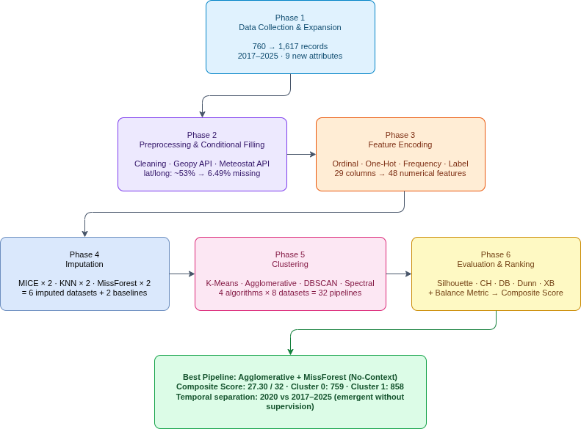

1.6 Research Contributions

The key contributions of this research are:
- A significantly expanded, cleaned, and enriched suicide dataset comprising 1,617 records and 34 columns, made available for the broader research community and covering suicide incidents across Bangladesh from 2017 to 2025.
- The first systematic benchmark comparing 32 imputation–clustering pipelines on real-world, severely incomplete Bangladeshi suicide data, covering three imputation methods, two predictor-selection strategies, and four clustering algorithms.
- A novel balance-aware composite evaluation metric that integrates five standard internal validity indices with a cluster size equity penalty, providing a fairer ranking criterion for naturally imbalanced social datasets.
- Actionable demographic, environmental, and geographic risk profiles derived from the best-performing pipeline (Agglomerative Clustering with MissForest no-context imputation), directly interpretable for prevention stakeholders.
- A demonstration that carefully designed imputation and clustering pipelines can recover temporally coherent, structurally meaningful patterns from data with over 90% missingness in several features — without any supervised labelling or domain-specific constraints imposed during modelling.

1.7 Thesis Organisation

The remainder of this report is organised as follows:
- Chapter 2 presents a background study and literature review covering existing research on suicide in Bangladesh, the challenges of newspaper-based datasets, and related work on missing data imputation and clustering in public health contexts.
- Chapter 3 describes the detailed research methodology, including the data collection and expansion process, the preprocessing and encoding pipeline, the three imputation strategies and their variants, the four clustering algorithms, and the composite evaluation framework.
- Chapter 4 discusses the implementation environment, experimental results across all 32 pipelines, group-level comparisons, and a detailed cluster-level profiling of the best-performing pipeline.
- Chapter 5 addresses engineering standards, societal impacts, ethical considerations, project challenges and constraints, and the project timeline.
- Chapter 6 concludes the thesis with a summary of findings, achievement of research objectives, limitations of the study, and directions for future work.

Chapter 2

Background Study and Literature Review

2.1 Introduction
Suicide is a complex and multifaceted public health issue shaped by psychological, social, economic, cultural, and environmental factors. In low- and middle-income countries (LMICs) such as Bangladesh, the challenge is compounded by the near-total absence of a national suicide registry and the pervasive problem of under-reporting, making it extremely difficult to obtain reliable, structured surveillance data. As a result, the most comprehensive data source available to researchers in this context remains newspaper and media reports — a source that is inherently rich in case-level detail yet severely limited by incompleteness and reporting bias [12, 13].
This chapter reviews the existing body of knowledge relevant to this study across four areas. Section 2.2 summarises what is currently known about suicide in Bangladesh based on empirical studies. Section 2.3 analyses the specific challenges associated with newspaper-based suicide datasets, with particular attention to the problem of missing data. Section 2.4 surveys the international literature on missing data imputation methods applied in public health and social research contexts. Section 2.5 reviews related work on unsupervised clustering applied to suicide and mental health data. Section 2.6 synthesises the identified research gaps that motivate the present study, and Section 2.7 provides a brief chapter summary.
2.2 Suicide in Bangladesh: Current Knowledge
Suicide in Bangladesh represents a serious and growing public health burden. Estimates from national health surveys and WHO reports suggest that approximately 10,000 or more people die by suicide annually in the country, though significant under-reporting is widely acknowledged in the literature [12, 13]. A comparative analysis of the Bangladesh Health and Injury Surveys from 2002 and 2015 found that suicide rates increased from 6.2 to 7.7 per 100,000 population over that period, with a particularly sharp rise among adolescents — from the elderly being the highest-risk group in 2002 to adolescents carrying the highest burden by 2015 [24]. These trends underscore the evolving and dynamic nature of the suicide landscape in Bangladesh.
The epidemiology of suicide in Bangladesh exhibits several consistent demographic and methodological patterns across studies. Hanging is by far the most common method, accounting for approximately 65–82% of completed suicides across different studies [2, 30], followed by poisoning, which is especially prevalent in rural areas where pesticides are readily available [13, 25]. Females, particularly young married women and female students, are disproportionately represented in suicide statistics — a pattern that reverses the global trend of male predominance [26]. A six-month newspaper content analysis found that 58% of reported cases were female, 24% were students, and 61% were from rural backgrounds, with marital and familial discord being the most frequently cited risk factor [2].
Rural areas consistently show substantially higher suicide rates than urban centres. A population-based study covering approximately 1.16 million people across seven sub-districts found that rural suicide rates were up to 17 times higher than urban rates [13]. Specific districts, including Jhenaidah, Chuadanga, Meherpur, and Narshingdi, have been identified as particularly high-burden areas. A dedicated study of Jhenaidah district recorded a suicide rate of 20.6 per 100,000 — well above both national and global averages — with females exhibiting higher suicide rates than males throughout the study period of 2010–2018 [27].
Among the most vulnerable sub-populations, students have received growing attention. A retrospective analysis of online news portals in Bangladesh found that 984 student suicide cases were identified in the post-pandemic period, with females accounting for 61% of these cases [28]. Contributing factors included academic pressure, board examination timing, family conflict, and failed relationships. COVID-19 further altered suicide patterns, with one study documenting a shift towards higher male incidence during the pandemic period, attributed to economic disruption and job loss among primary breadwinners [29].
Despite this accumulating body of work, the majority of existing Bangladeshi studies share a critical limitation: they rely on manual or semi-automated extraction from newspaper sources and explicitly acknowledge the problem of incomplete records. Variables such as age, exact location, reason for suicide, socioeconomic status, and prior mental health history are frequently absent or inconsistently recorded, severely restricting the depth of analysis that can be conducted [2, 12].
2.3 Challenges with Newspaper-Based Suicide Datasets
Newspaper and media-based datasets represent the primary — and often the only — source of case-level suicide data in resource-constrained settings such as Bangladesh. A systematic review of media-based suicide research in LMICs concluded that content analyses of newspaper reports are the dominant research methodology in these settings, driven largely by the absence of alternative data sources and the relatively low cost of media analysis compared to structured epidemiological surveys [31].
However, this reliance comes with well-documented structural limitations. The most critical is the problem of missing data. Reporters covering suicide incidents rarely collect or record the full demographic, socioeconomic, and contextual details that would be required for meaningful quantitative analysis. As a result, critical variables are systematically absent across a large proportion of cases. The following table summarises the key features affected by missingness in newspaper-based datasets, based on consistent patterns reported across the Bangladeshi suicide literature [2, 12, 13, 27]:
Feature Category | Typical Missingness Rate | Impact on Analysis
Age / age group | 10–25% | Limits age-specific risk profiling
Exact location (lat/long) | 40–70% | Prevents geospatial analysis
Reason for suicide | 15–40% | Weakens causal inference
Socioeconomic indicators | 50–90% | Prevents analysis of poverty and debt links
Weather / environmental data | >60% | Blocks study of seasonal or climatic triggers
Prior mental health history | >90% | Almost impossible to study recurrence
Table 2.1: Typical missingness in newspaper-based suicide datasets in Bangladesh
Beyond missingness, newspaper-based datasets are subject to additional limitations. They are inherently biased towards cases that are deemed newsworthy — typically those involving unusual methods, public locations, or prominent individuals — meaning that common, unremarkable suicides in remote rural areas are systematically under-reported [31]. Reporting inconsistencies in spelling, categorical labels, and temporal formats further complicate data preparation. These challenges force researchers either to perform complete-case analysis — which dramatically reduces sample size and introduces selection bias — or to apply naive imputation strategies such as mean substitution, which introduces distributional bias [14, 15].
2.4 Related Work on Missing Data Imputation in Public Health
The problem of missing data in real-world datasets has generated a substantial methodological literature, particularly within public health and clinical research. Three families of imputation approaches have emerged as dominant in the recent literature: Multiple Imputation by Chained Equations (MICE), K-Nearest Neighbours (KNN) imputation, and ensemble tree-based methods, most notably MissForest.
MICE, originally formalised by Van Buuren and Groothuis-Oudshoorn (2011) [8], operates by iteratively fitting a series of regression models — one per variable — conditioned on all other variables. Its flexibility for mixed-type data (continuous and categorical) and its principled treatment of uncertainty through multiple imputation have made it one of the most widely recommended methods in clinical and epidemiological research. KNN imputation, introduced to the bioinformatics literature by Troyanskaya et al. (2001) [9], fills missing values using the weighted average of the k most similar complete observations. It is computationally efficient and does not impose distributional assumptions, though its performance degrades when datasets are high-dimensional or when local neighbourhood structure is disrupted by high missingness.
MissForest, proposed by Stekhoven and Bühlmann (2012) [10], takes a fundamentally different approach: it trains a separate random forest model for each variable, using all other variables as predictors, and iterates until convergence. This non-parametric, ensemble-based strategy makes it particularly robust to non-linear relationships, interactions, and mixed data types without requiring the specification of explicit regression models. Multiple comparative studies have confirmed MissForest's superiority over MICE and KNN in medical and biological datasets characterised by moderate to high missingness and complex variable interactions [10, 18, 19].
The following table summarises the most relevant comparative imputation studies, focusing on their domain, methods tested, and key findings:
Study | Domain | Methods Compared | Key Finding
Stekhoven & Bühlmann (2012) [10] | Bioinformatics / mixed-type data | MissForest vs. MICE vs. KNN | MissForest outperforms MICE and KNN on mixed-type data, reducing imputation error by up to 60% in some datasets.
Nijman et al. (2021) [15] | Electronic health records | MICE vs. basic imputation | Multivariate imputation by MICE consistently reduces bias in feature selection compared to simple imputation techniques.
Alkhateeb et al. (2024) [18] | Medical datasets (10 datasets) | MICE, KNN, MissForest, RFE-MF | MissForest consistently outperforms KNN and MICE across diverse medical datasets at missingness rates of 10–50%.
Hamdan et al. (2025) [19] | Healthcare diagnostics | MICE, KNN, MissForest, mean/median | MissForest achieves lowest RMSE and MAE; MICE ranks second; KNN performance is inconsistent across datasets.
Jarrett et al. (2021) [16] | 69 real-world tabular datasets | Multiple imputation methods | No single imputation method dominates across all data types and missingness patterns; context-specific evaluation is essential.
Table 2.2: Summary of related work on missing data imputation in public health and related domains
Despite this growing body of comparative work, several important gaps remain. First, the vast majority of imputation benchmarks are conducted on clinical or genomic datasets from high-income settings, and very few have systematically evaluated imputation methods on incomplete social and behavioural datasets from South Asia [16]. Second, most studies evaluate imputation quality in isolation — measuring reconstruction error relative to artificially masked values — rather than assessing the downstream impact of imputation choices on unsupervised learning tasks such as clustering [16, 17]. Third, no prior work has examined the specific problem of predictor selection during imputation — that is, whether using all available columns or only contextually correlated predictors leads to meaningfully different cluster structures — which is one of the novel dimensions explored in the present study.
2.5 Related Work on Clustering in Suicide and Mental Health Research
Unsupervised clustering has been increasingly applied to mental health and suicide data as a means of identifying latent subgroups within heterogeneous populations. Unlike supervised approaches that require labelled outcomes, clustering allows the data itself to reveal structure — a particularly appropriate strategy when, as in the present study, no ground-truth class labels exist.
At the broadest level, Orchard et al. (2024) [20] applied K-Means and hierarchical clustering to a large Canadian community health survey, identifying four distinct mental health profiles with meaningfully different healthcare service-use patterns. Their work demonstrated that unsupervised methods can reveal clinically and policy-relevant subgroups in population-level mental health data that would not be apparent through traditional regression approaches.
More directly relevant to the suicide context, Xiao et al. (2025) [21] published what is described as the first study to apply unsupervised machine learning to a comprehensive set of social determinants of health specifically for suicide risk across U.S. communities. Using K-Means clustering on large population-level data, they identified geographically coherent community-level risk clusters — including one characterised by social isolation and poor healthcare access, and another by economic distress and family instability — each requiring distinct prevention strategies. This work closely parallels the motivations of the present study, though the U.S. context, the availability of structured administrative data, and the focus on community-level rather than individual-level variables make the methodological challenges substantially different from those encountered with incomplete Bangladeshi newspaper data.
Kim et al. (2025) [22] applied agglomerative nesting followed by K-Means to psychological autopsy data from 391 suicide deaths in Spain, identifying three impulsivity-based subprofiles. Their study highlights the significant heterogeneity among individuals who die by suicide — a finding that directly motivates the use of clustering over aggregate-level analyses. Ong et al. (2022) [23] used cluster analysis on stressor and risk factor data from student suicides in Hong Kong, identifying four meaningful profiles (school distress, hidden, family and relationship, and numerous issues), each with distinct prevention implications.
In the Bangladeshi context specifically, prior studies have not applied any form of algorithmic clustering to suicide data. Arafat et al. (2018) [2], one of the most cited newspaper-based analyses of Bangladeshi suicides, explicitly acknowledged that high levels of missingness in the dataset precluded any systematic subgroup analysis beyond basic cross-tabulation. This observation directly identifies the methodological gap that the present study addresses.
The following table summarises the most relevant clustering studies in the suicide and mental health domain:
Study | Country / Data | Clustering Approach | Main Finding
Orchard et al. (2024) [20] | Canada (community health survey) | K-Means, hierarchical clustering | Four distinct mental health profiles identified, each associated with different healthcare service-use patterns.
Xiao et al. (2025) [21] | USA (social determinants data) | Unsupervised machine learning (K-Means) | First study to use unsupervised ML on social determinants of health for suicide; community-level risk clusters identified.
Kim et al. (2025) [22] | Spain (psychological autopsy, 391 cases) | Agglomerative nesting + K-Means | Three impulsivity-based suicide profiles identified; highlights significant heterogeneity among suicide decedents.
Ong et al. (2022) [23] | Hong Kong (student suicides) | Cluster analysis on stressors and risk factors | Four student suicide profiles found (school distress, hidden, family/relationship, numerous issues); supports differentiated interventions.
Arafat et al. (2018) [2] | Bangladesh (newspaper data) | Manual grouping only | No algorithmic clustering applied; missingness in newspaper data cited as primary barrier to advanced analysis.
Table 2.3: Summary of related work on clustering in suicide and mental health research
A critical observation across all reviewed clustering studies is that none of them systematically varied both the imputation strategy and the clustering algorithm to understand how imputation choices affect downstream cluster quality. Furthermore, existing studies have almost universally relied on standard internal validity indices — Silhouette score, Calinski–Harabasz, and Davies–Bouldin — without accounting for the practical problem of cluster size imbalance [32, 33]. When one cluster contains the vast majority of observations and another contains only a handful of outliers, standard validity indices can still report high scores, making the solution appear better than it is in practice. This limitation is particularly acute in real-world social datasets where natural group imbalance is the norm rather than the exception.
2.6 Problem Analysis and Research Gap
From the foregoing review, the following critical gaps emerge that directly motivate the design of the present study:
Gap 1 — No large-scale, enriched suicide dataset for Bangladesh: The largest existing newspaper-based Bangladeshi suicide datasets contain at most a few hundred records with limited attributes and cover single years. No publicly available dataset systematically covers multiple years (2017–2025) or includes socioeconomic, clinical, and environmental attributes alongside the basic demographic information.
Gap 2 — No systematic imputation benchmark for this data type: While the international imputation literature is extensive, no study has systematically benchmarked state-of-the-art imputation methods (MICE, KNN, MissForest) on a large, real-world, newspaper-derived social dataset from South Asia with the extreme missingness levels characteristic of this domain (50–90% for several key variables).
Gap 3 — No multi-method clustering study on Bangladeshi suicide data: No published work has applied multiple clustering algorithms to Bangladeshi suicide records, let alone examined how the choice of imputation method influences the resulting cluster structure. The only existing clustering applications in this domain have been conducted on Western datasets with structured, near-complete data.
Gap 4 — No evaluation framework accounting for cluster imbalance: Standard internal clustering validity indices do not penalise solutions where a single cluster dominates the data or where density-based algorithms classify the majority of points as noise. For naturally imbalanced social datasets, a fairness-aware evaluation component is needed to distinguish practically useful clusterings from statistically artefactual ones.
Gap 5 — No consideration of predictor selection effects during imputation: Existing comparative imputation studies rarely examine how the choice of predictor set — using all available columns versus only contextually correlated ones — affects both imputation quality and downstream clustering outcomes. This dimension is entirely unexplored in the Bangladeshi public health context.
The present study directly addresses all five gaps by: (1) expanding the publicly available dataset from 760 to 1,617 cases with 9 new attributes covering 2017–2025; (2) implementing an exhaustive 32-pipeline comparison of three imputation methods under two predictor strategies and four clustering algorithms; (3) introducing a composite scoring framework that incorporates a novel balance metric alongside five standard validity indices; and (4) providing fully interpretable, actionable cluster profiles grounded in the Bangladeshi social context.

Table 2.4 positions the present study against the most closely related prior work across five key methodological dimensions, highlighting how it addresses each of the identified research gaps.

Dimension | Arafat et al. 2018 [30] | Xiao et al. 2025 [21] | Kim et al. 2025 [22] | Jarrett et al. 2021 [16] | This Study
Country / Context | Bangladesh | USA | Spain | 69 datasets | Bangladesh
Data source | Newspaper | Administrative | Clinical autopsy | Various | Newspaper
Dataset size | ~200 cases | Large population | 391 cases | Varies | 1,617 cases
Missing data handling | None / complete case | Not applicable | Not applicable | Imputation benchmarks | MICE + KNN + MissForest × 2 strategies
Clustering applied | None | K-Means only | Agglomerative + K-Means | None | 4 algorithms × 8 datasets = 32 pipelines
Evaluation metric | Manual grouping | Standard metrics | Standard metrics | RMSE / reconstruction | 5 standard + novel balance metric
Multi-year coverage | Single year | Multiple years | Single study | N/A | 2017–2025
Reproducible pipeline | No | Partial | No | Yes | Yes (12 notebooks, open source)
Novel metric proposed | No | No | No | No | Yes (balance metric)

2.7 Summary
This chapter has established that suicide in Bangladesh is a serious and growing public health concern, with consistent demographic patterns emerging across two decades of newspaper-based research — including the predominance of hanging as method, over-representation of young females and students, sharp rural–urban disparities, and high-burden districts such as Jhenaidah and Chuadanga. It has also demonstrated that newspaper data remains the only comprehensive source of case-level suicide information in Bangladesh, but that this source is characterised by extreme and non-random missingness that fundamentally limits the analytical methods that can be applied.
The international literature on missing data imputation provides a strong methodological foundation: MissForest consistently outperforms MICE and KNN on mixed-type data with moderate to high missingness, though no benchmark has been conducted in the specific context of newspaper-based social data from South Asia. The clustering literature confirms that unsupervised methods can identify meaningful, intervention-relevant subgroups from mental health data, but no such analysis has been attempted on Bangladeshi suicide records, and no existing study has jointly optimised imputation and clustering or evaluated solutions with a fairness-aware metric.
The identified research gaps collectively justify the methodological focus of the present study. Chapter 3 describes the comprehensive research framework designed to address these gaps.

Chapter 3

Research Methodology

3.1 Overview of the Proposed Framework
This study follows a systematic, reproducible methodological framework specifically designed for highly incomplete, mixed-type, real-world social datasets. The complete pipeline consists of six major phases:
- Data Collection and Expansion
- Intensive Preprocessing and Conditional Filling
- Advanced Feature Encoding
- Multiple Imputation Strategies (three imputation methods × two predictor-selection approaches)
- Clustering Using Multiple Algorithms
- Comprehensive Evaluation and Comparison
Through this pipeline, a total of eight datasets were generated—six fully imputed datasets and two non-imputed baseline datasets. Each dataset was clustered using four distinct clustering algorithms, producing 32 clustering solutions in total. These solutions were subsequently evaluated and ranked using a composite internal validation scoring framework.

3.2 Dataset Analysis

3.2.1 Data Collection and Expansion
The base dataset was obtained from Kaggle [3], containing suicide-related records from Bangladesh:
- Source: Kaggle – Bangladesh Suicide Dataset
- Initial size: 760 records × 27 columns
- Coverage: Year 2020
To enhance temporal coverage and analytical richness, 857 additional recent cases were manually collected. The dataset was expanded to cover incidents from 2017 to 2025. These records were compiled from verified national and local Bangladeshi news outlets, including Prothom Alo, The Daily Star, Jugantor, Ittefaq, and multiple regional newspapers and online portals.
To capture socio-economic and clinical dimensions absent in the original dataset, nine new attributes were introduced:
- family_members
- position_in_siblings
- marital_status
- duration_of_separation
- profession_description
- workplace
- financial_condition
- previous_health_condition
- Previous_suicide_attempt
After expansion, the final dataset statistics were:
- Total records: 1,617
- Total columns: 36

3.2.2 Removal of Irrelevant and Sensitive Columns
To address ethical concerns and analytical redundancy, the following columns were permanently removed:
- full_name: removed to avoid the use of personally identifiable information
- data_source: removed as the news URL did not contribute to clustering or analysis

3.2.3 Missing Value Analysis (Pre-Imputation)
Before applying any imputation, an extensive analysis of missing values was conducted. Features were grouped into four categories based on their percentage of missing values:
Group | Missing Range | Key Columns
1 | 77.61% - 96.17% | duration_of_separation, position_in_siblings, previous_suicide_attempt, previous_health_condition, family_members
2 | 45.51% - 53.06% | Weather-related variables (temp_min, temp_max), latitude, longitude, profession_description, financial_condition etc
3 | 23.93% - 37.90% | workplace, marital_status
4 | 0.43% - 18.92% | age, gender, method, reason, hometown, etc
All Group 1 variables (missing rate >70%) were permanently excluded from further analysis, as imputing such highly sparse features would introduce excessive uncertainty and noise [1].

3.3 Detailed Preprocessing Pipeline

3.3.1 Column Standardization & Type Correction
The dataset contained inconsistencies in naming conventions, spelling, and data types. The following corrective actions were applied:
- Converted all column names to snake_case
- Corrected spelling errors (e.g., maritual_status → marital_status)
- Converted numerical values stored as strings to appropriate integer or float types

3.3.2 Date & Time Standardization
The suicide_date column existed in multiple formats (string, datetime, and numeric). Additionally, the time column was categorical (morning, noon, evening, night). To ensure consistency:
- All dates were standardized to DD/MM/YYYY format
- Categorical time values were mapped to representative hours (0–23)
- Five temporal features were derived:
  - suicide_day
  - suicide_month
  - suicide_year
  - suicide_week
  - suicide_weekday

3.3.3 Categorical Value Harmonization (Manual + Semi-automated)
Categorical variables exhibited extensive inconsistencies due to spelling variations, synonym usage, casing differences, and over-granular labels. The number of unique categories ranged from 7 (gender) to 594 (hometown).
A column-wise iterative cleaning process was applied:
- Spelling variants and synonyms were merged
- Similar categories were grouped into broader, semantically consistent classes
- The hometown feature was simplified to district-level labels only to reduce sparsity and address ethical concerns
This process was repeated iteratively for each categorical column until no duplicate semantic categories remained. After harmonization, the highest cardinality column (hometown) was reduced to 151 unique categories.

3.3.4 Conditional Filling Using External APIs
To reduce missingness without arbitrary imputation, external data sources were conditionally integrated:
Geolocation (Latitude & Longitude): Using the cleaned hometown field and the Geopy geocoding service, missing latitude and longitude values were filled. Missingness was reduced from ~53% to 6.49% for both variables.
Unix Time Construction: Using suicide_date and encoded time, a unix_time feature was computed, reducing missingness from 52.38% to 5%.
Weather Variables: Weather attributes were conditionally filled using the Meteostat API, leveraging the unix_time, latitude, and longitude. Hourly data were prioritized; daily aggregates were used when hourly data were unavailable.
Column | Before | After | Status
temp_min | 53.06% | 29.87% | Reduced
temp_max | 53.06% | 29.56% | Reduced
air_pressure | 53.06% | 30.43% | Reduced
air_humidity | 53.06% | 53.06% | No Change
wind_speed | 52.99% | 30.18% | Reduced
wind_deg | 53.06% | 53.06% | No Change

Values for air_humidity and wind_deg didn’t change because the data for these columns for teh given dates and location were not present in API.

No values were filled for feels_like, clouds_sky, weather_main, and weather_description due to the unavailability of data in the API for the given spatiotemporal conditions.

3.3.5 Feature Engineering & Final Cleaning
The following steps were applied before encoding:
- Dropped long free-text columns (profession_description, reason_description)
- Removed suicide_date and unix_time after feature extraction
Final feature set: 29 columns (13 categorical, 16 numerical)

3.3.6 Encoding Strategy

To convert categorical variables into numerical representations suitable for imputation and clustering, four encoding techniques were applied based on feature characteristics:
Ordinal Encoding:
Certain categorical variables exhibit an intrinsic and meaningful order among their categories. For such variables, ordinal encoding was employed to preserve relative ordering information in numerical form. This encoding was applied to the following features:
- age_group
- financial_condition
- weather_main
- suicide_weekday
The mappings were manually defined based on domain knowledge to ensure semantic correctness. For example, the age_group feature was encoded as: {baby=0, child=1, teen=2, young=3, adult=4, middle-aged=5, old=6}
One-Hot Encoding:
Low-cardinality nominal variables without inherent ordering were encoded using one-hot encoding. This approach was applied to the following features:
- gender
- workplace
- Religion
Frequency (Proportional) Encoding:
High-cardinality categorical variables without ordinal structure were encoded using proportional frequency encoding. This method was applied to:
- profession_group
- hometown
- reason
- method
- weather_description
- marital_status
Applying one-hot encoding to these features would result in a highly sparse feature space, which could lead to the curse of dimensionality and adversely affect clustering performance.
Therefore, proportional frequency encoding was chosen over raw count encoding due to its Efficient Handling of High Cardinality, preserving meaningful patterns, and improving model interpretability [4].
Formally, for a categorical feature $X$ and a category $c∈X$, the proportional frequency encoding value $f(c)$ is defined as:
$f(c)=\frac{N_{c}}{N}$
where:
- $Nc$ is the number of occurrences of category $c$ in feature $X$,
- $N$ is the total number of non-missing observations in the feature $X$.
Encoded values were stored in newly created columns to preserve the original categorical variables for interpretability and post-clustering analysis.
Numerical Features:
All numerical variables were retained in their original form, as they were already represented in appropriate integer or floating-point formats.
After applying all encoding procedures, the final dataset consisted of 48 numerical features, making it fully prepared for downstream imputation and clustering.
Label Encoding (special case):
For the special case of imputing the dataset with missForest, all of the columns were encoded with the numeric labels using the LabelEncoder from scikit-learn.

Decoding preparation:
The encoding mappings for all categorical variables were saved in JSON files to enable consistent decoding after clustering, facilitating interpretation of results, cluster profiling, and visualization of real-world patterns.

3.4 Imputation Strategies
Missing values in the dataset, stemming from incomplete newspaper reports on suicide cases, were handled through multivariate imputation to retain sample size, reduce bias, and preserve the integrity of features such as demographics (e.g., age, gender, profession_group), spatiotemporal factors (e.g., latitude, longitude, suicide_date), and environmental variables (e.g., temperature, weather_main). Three established imputation methods were selected: Multiple Imputation by Chained Equations (MICE), K-Nearest Neighbors (KNN), and MissForest. These methods were chosen to span a range of approaches—parametric and model-based (MICE), non-parametric and instance-based (KNN), and ensemble tree-based (MissForest)—enabling a comprehensive comparison of their performance on mixed-type data with varying missingness patterns. This multi-method strategy aligns with best practices for robust imputation evaluation, as no single technique is universally optimal.
For each method, two predictor selection strategies were applied, resulting in six variants. Parameters were standardized where possible (e.g., 10 iterations for convergence in iterative methods, k=5 for KNN) to ensure fair comparisons. All imputations were implemented in Python using libraries such as scikit-learn (for MICE via IterativeImputer with BayesianRidge estimator, KNNImputer) and the missForest package equivalents. Post-imputation, residual missing values were ≤0.25% across all variants, yielding effectively complete datasets.

3.4.1 Common Functionalities of All Three Methods
3.4.1.1 Predictor Selection Strategies
Two strategies were employed for predictor selection to cover both selective and inclusive scenarios, allowing evaluation of their impact on imputation quality.
3.4.1.1.1 Correlation-based (Context-aware Selection)
For each target column, pairwise Pearson correlation coefficients were computed with all other columns using pandas' corr() function (defaulting to Pearson correlation). Self-correlations (always 1.0) were excluded, and only non-zero correlations (|r| > 0.0) were retained. A sorted dictionary of predictors was created, ordered by descending absolute correlation value. Only these correlated columns were used as predictors, focusing on informative relationships to reduce noise, multicollinearity, and computational burden while enhancing imputation quality.
3.4.1.1.2 All-available (No-context Selection)
This baseline used all columns in the dataset (except the target column itself) as predictors, maximizing available information but potentially including weakly related or redundant variables.
3.4.1.2 Constraints
To prevent unrealistic imputed values (e.g., negative temperatures or latitudes outside Bangladesh), post-prediction constraints were applied to selected numerical, temporal, and encoded columns. Constraints were derived from domain knowledge, geographical facts, historical weather records, and logical limits. Examples include age (0–100 years), latitude and longitude (Bangladesh-specific geographic bounds), temperature-related columns (feels_like, temp_min, temp_max: plausible regional Kelvin range), wind_deg (0–360°), and encoded ordinal columns (e.g., suicide_weekday_encoded: 0–6). Values were rounded (for integers) and clipped to these bounds.
3.4.1.3 Functions Overview (Generalized Workflow)
Custom Python functions processed the imputation column-by-column and took as input the target column_name, DataFrame df, predictor selection dictionary (context-aware or no-context), and constraints dictionary.
The common workflow was as follows:
- Identify rows with missing values in the target column.
- For each missing row, dynamically select usable predictors (non-null in that row).
- If no usable predictors exist, skip the row.
- Prepare training data from complete cases in df (rows where target and selected predictors are non-null).
- Train an appropriate model and predict the missing value (missing predictors temporarily filled with column mean for numerics or mode for categoricals).
- Apply rounding (if needed) and clipping to constraints.
- Update the DataFrame with the imputed value.
This shared structure ensured consistency across methods, with differences arising from model type and encoding compatibility. A visual overview of the workflow is provided in Figure 3.1 (with branches for context-aware vs. no-context predictor selection).
Figure 3.1 Unified imputation workflow for MICE, KNN, and MissForest (context-aware vs. no-context variants).
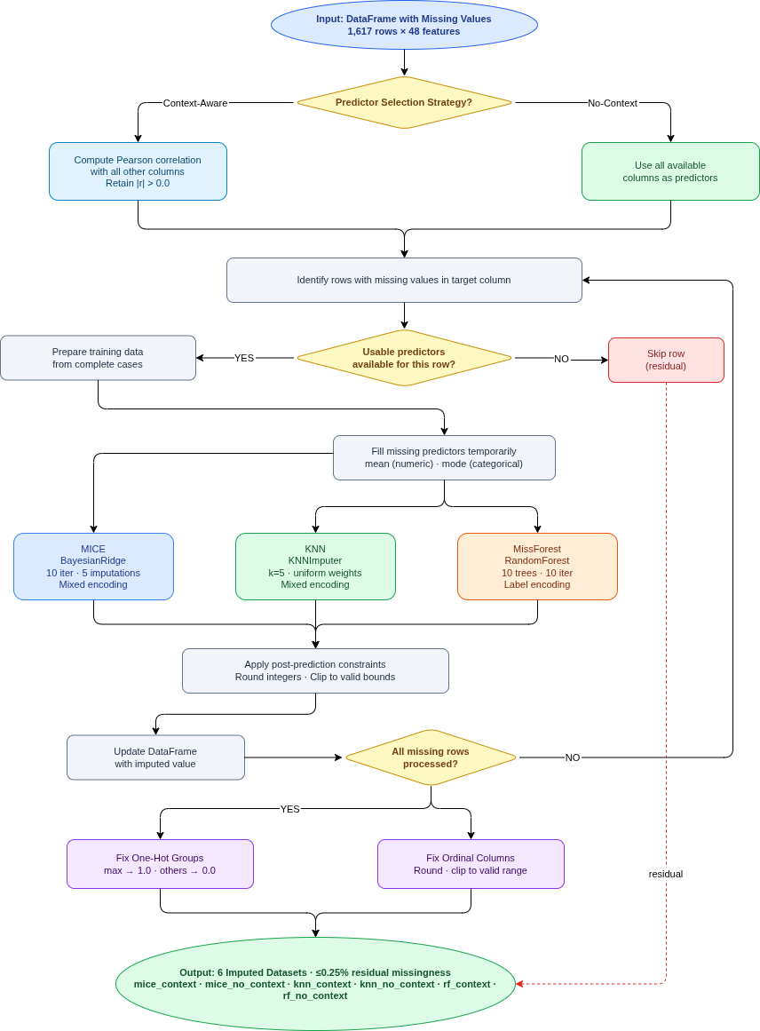
3.4.2 Method-Specific Adaptations
3.4.2.1 Multiple Imputation by Chained Equations (MICE)
MICE is a flexible, iterative parametric method that models each variable conditionally on the others using chained regression equations, generating multiple plausible imputations to account for uncertainty [5]. It is particularly suitable for mixed-type data under MAR assumptions.
In this implementation, MICE used scikit-learn's IterativeImputer with a BayesianRidge estimator (10 iterations, 5 imputations). Both context-aware and no-context variants followed the generalized workflow, with MICE supporting mixed encodings (one-hot, frequency, ordinal) natively.
3.4.2.2 K-Nearest Neighbors (KNN)
KNN is a non-parametric instance-based method that fills missing values by averaging (or mode for categoricals) from the k most similar complete observations based on distance metrics [7]. It is simple, fast, and robust to local patterns.
Here, scikit-learn’s KNNImputer was used (k=5, uniform weights). The method supported mixed encodings and followed the same generalized workflow for both predictor strategies.
3.4.2.3 MissForest
MissForest is a non-parametric iterative method that uses random forests to impute missing values, capturing non-linear interactions without distributional assumptions [6]. It was applied with 10 trees per forest and max 10 iterations.
Label encoding was preferred for categoricals to optimize tree-based performance (unlike mixed encoding for MICE/KNN). Imputed categorical values were rounded and clipped to valid integer ranges post-imputation to match the original encoding.
3.4.3 Post-Imputation Processing
After imputation, processing ensured categorical integrity and was identical across all variants.
3.4.3.1 Fixing One-Hot Encoded Columns
One-hot encoded groups (e.g., gender: female/male/third gender; workplace: rural/semi-urban/urban; religion: buddhist/christian/hindu/indigenous/muslim) sometimes produced fractional or multiple active values. These were corrected by setting the column with the highest imputed value to 1.0 and all others in the group to 0.0 per row.
3.4.3.2 Fixing Ordinal Encoded Columns
Ordinal columns (e.g., suicide_weekday_encoded: 0–6; age_group_encoded: 0–6; financial_condition_encoded: 0–4; weather_main_encoded: 0–7) were rounded from floats to nearest integers and clipped to valid bounds to restore semantic meaning.
3.4.4 Summary of Imputation Variants
The table below summarizes the six variants, including abbreviations and missingness reduction (initial missingness varied by column; post-imputation ≤0.25% for all).
Imputation Method | Predictor Strategy | Abbreviation Used | Notes On Implementation
MICE | Correlation-based context | mice_context | BayesianRidge, mixed encoding
MICE | All available columns | mice_no_context | BayesianRidge, mixed encoding
KNN | Correlation-based context | knn_context | KNNImputer, mixed encoding
KNN | All available columns | knn_no_context | KNNImputer, mixed encoding
MissForest | Correlation-based context | rf_context | RandomForest, label encoding + rounding
MissForest | All available columns | rf_no_context | RandomForest, label encoding + rounding

3.5 Clustering Algorithms
3.5 Clustering Algorithms
3.5.1 Dataset Preparation for Clustering
The clustering analysis was performed on 8 distinct datasets to enable a comprehensive comparison between imputed and non-imputed versions. The 6 imputed datasets were generated from the three imputation methods (MICE, KNN, MissForest) using two predictor selection strategies (context-aware and no-context), each with 1613 rows and 37 columns after imputation.
For baseline comparison, a non-imputed version (df_encoded) was created by applying manual imputation, logical fillings, and encoding to the original data, resulting in varying missingness levels across columns. A missing data report revealed no columns with >53.06% missing, but significant missingness in groups: >45.51% to ≤53.06% (e.g., feels_like, air_humidity at 53.06%), >23.93% to ≤37.90% (e.g., workplace_encoded at 37.90%), and ≤18.92% (e.g., profession_group_encoded at 18.92%).

To create complete baseline datasets, rows with any missing values were dropped. Three variants were formed based on missingness thresholds:
- df_encoded_20: Columns with ≤18.92% missing (853 rows, 22 columns)
- df_encoded_40: Columns with ≤37.90% missing (403 rows, 30 columns)
- df_encoded_50: All columns (≤53.06% missing, but effectively all since max was 53.06%; 57 rows, 37 columns)
The df_encoded_50 was excluded due to insufficient rows (57) for meaningful clustering. Thus, the final 8 datasets were: df_encoded_20, df_encoded_40, and the 6 imputed versions. These were compiled into a collection for batch processing, ensuring consistent application of clustering pipelines.
3.5.2 Overview and Rationale
Clustering was applied as an unsupervised technique to discover hidden patterns in the suicide dataset, where no predefined target variable existed for prediction. Four diverse algorithms were selected to cover different clustering paradigms: centroid-based (K-Means), hierarchical (Agglomerative Clustering), density-based (DBSCAN), and graph-based (Spectral Clustering). This selection provided robustness, as each method handles data structures differently—K-Means works with neighbors and means, Agglomerative uses hierarchical merging, DBSCAN focuses on density, and Spectral Clustering employs graph-based partitioning.
The goal was to evaluate performance across the 8 input datasets (6 imputed + 2 baselines), resulting in 32 combinations, using a combined scoring system to identify the best pipeline. This allowed assessment of how imputation strategies influenced cluster quality and revealed real-world suicide patterns (e.g., demographic or environmental groupings), proving the pipeline's utility.
3.5.3 Common Preprocessing and Evaluation
All clustering methods shared a standardized preprocessing and evaluation pipeline to ensure fair comparison, with parameters tuned dynamically via grid search or fine-tuning.
3.5.3.1 Preprocessing Pipeline
Data was preprocessed to normalize features and reduce dimensionality. Numerical columns were scaled using StandardScaler (mean 0, std 1), ensuring equal contribution to distance metrics. Principal Component Analysis (PCA) was applied to compress high-dimensional data while retaining significant variance (e.g., 99% variance or fixed n_components like 10 or 20), improving efficiency and reducing noise while preserving key patterns.
3.5.3.2 Optimal Cluster Number Determination
The optimal number of clusters (k) was determined using silhouette analysis (measuring cluster cohesion/separation) and the elbow method (plotting inertia/distortion vs. k to find the "elbow" point). Tested ranges varied by method (e.g., 2–20 for K-Means, 2–11 for Agglomerative, 2–6 for Spectral), applied per dataset to adapt to varying input structures.
3.5.3.3 Hyperparameter Tuning Strategy
Hyperparameters were optimized using grid search followed by fine-tuning, with subset sampling (e.g., 1000 rows) for computational efficiency on large datasets. Performance was evaluated using the silhouette score (higher better), the Calinski-Harabasz index (higher better), and the Davies-Bouldin index (lower better). These were combined into a method-specific composite score for selection of the best parameter set. Parallel processing was utilized where applicable to accelerate the search.
3.5.4 Method-Specific Adaptations
3.5.4.1 K-Means (Centroid-based)
K-Means partitions data into k clusters by minimizing within-cluster variance around centroids, iteratively assigning points to the nearest centroid, and updating positions [8]. It is fast, scalable, and widely used, but assumes spherical, equally sized clusters.
The implementation employed dynamic hyperparameter tuning via grid search and fine-tuning. Key search spaces included n_clusters (range 2–20), init methods ('k-means++', 'random'), n_init (10, 20, 50), and max_iter (300, 500), with preprocessing via StandardScaler and optional PCA (retaining 99% variance). Grid search evaluated all combinations using the silhouette score (sil, higher better) and Davies–Bouldin score (db, lower better), selecting the best set via the combined score sil / (db + 1e-12). Fine-tuning refined n_clusters around the best value (±2, minimum 2) using the same formula, updating only if performance improved. Final cluster labels were saved in a new column 'kmeans_cluster'. This process was repeated independently for all 8 datasets.
3.5.4.2 Agglomerative Clustering (Hierarchical)
Agglomerative Clustering builds a hierarchy by merging the closest clusters bottom-up, using linkage criteria to define the distance between clusters [9]. It handles arbitrary shapes, provides dendrograms for visualization, and does not require a predefined number of clusters.
The implementation used dynamic hyperparameter tuning with sampling for efficiency. Key search spaces included n_clusters (range 2–10), linkage methods ('ward', 'complete', 'average'), and metrics ('euclidean', 'manhattan', 'cosine'), with preprocessing via StandardScaler and PCA (n_components=10). Tuning sampled 1000 rows and evaluated combinations using silhouette score (sil), Calinski-Harabasz index (ch), and Davies-Bouldin index (db), with a combined score (sil + ch_norm + db_norm)/3 where ch_norm = ch / (ch + 1e-6) and db_norm = 1.0 / (1.0 + db). The best set was selected based on the highest combined score. Final cluster labels were saved in a new column 'agg_cluster'. This process was repeated for all 8 datasets.
3.5.4.3 DBSCAN (Density-based)
DBSCAN groups points in high-density regions while marking low-density points as noise, identifying clusters of arbitrary shape without requiring a predefined number of clusters [10]. It is robust to outliers but sensitive to parameter choices.
The implementation used dynamic hyperparameter tuning with sampling for efficiency. Key search spaces included eps (0.3–2.0 in 0.1 increments), min_samples (3, 5, 8, 10, 15), and metrics ('euclidean', 'manhattan', 'cosine'), with preprocessing via StandardScaler and PCA (n_components=10). Tuning evaluated combinations using silhouette score (sil), Calinski-Harabasz index (ch), and Davies-Bouldin index (db), with a combined score (sil + ch_norm + db_norm)/3 where ch_norm = ch / (ch + 1e-6) and db_norm = 1.0 / (1.0 + db). The best parameter set was selected based on the highest combined score. Final cluster labels (noise labeled as -1) were saved in a new column 'dbscan_cluster'. This process was repeated for all 8 datasets.
3.5.4.4 Spectral Clustering (Graph-based)
Spectral Clustering constructs a similarity graph and uses eigenvalues of the graph Laplacian to partition data into non-linear clusters [11]. It excels at capturing complex, non-convex boundaries.
The implementation used dynamic hyperparameter tuning with optional subsampling for efficiency. Key search spaces included n_clusters (range 2 to 6), affinity ('nearest_neighbors'), and assign_labels ('kmeans'), with preprocessing via StandardScaler and PCA (n_components=20). Tuning evaluated combinations using silhouette score (sil), Calinski-Harabasz index (ch), and Davies-Bouldin index (db), with a combined score sil + np.log(ch + 1) - db. The best parameter set was selected based on the highest combined score. Final cluster labels were saved in a new column 'spc_cluster'. This process was repeated for all 8 datasets.

3.5.5 Overall Clustering Pipeline
The pipeline processed each of the 8 datasets uniformly: input DataFrame → preprocessing (scaling + PCA) → hyperparameter tuning (grid search/fine-tuning with combined scoring) → application of the best model → addition of cluster labels column (e.g., 'kmeans_cluster'). This ensured comparability across methods and inputs.
Figure 3.2 Flowchart of the clustering pipeline.
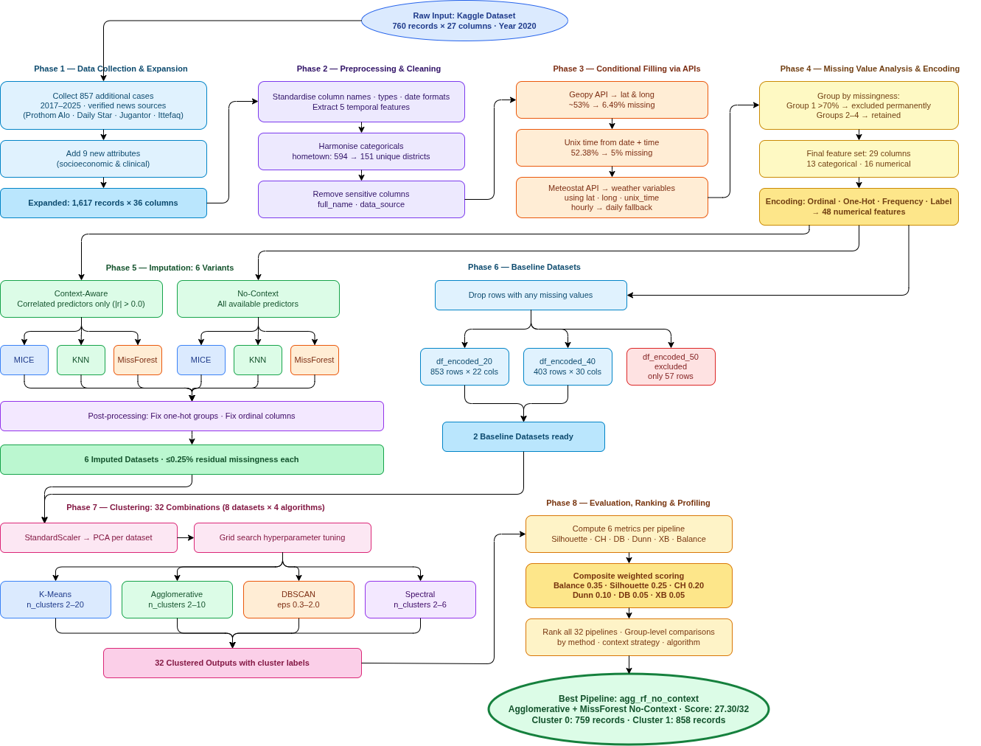
3.5.6 Summary of Clustering Combinations
The table below summarizes the 32 combinations (8 inputs × 4 methods), including abbreviations and example metrics (actual values from analysis; e.g., silhouette score).
Input Dataset | Clustering Method | Abbreviation | Imputation Method
df_encoded_20  (853 rows, 22 cols) | K-Means | kmeans_encoded_20 | Baseline, no imputation
df_encoded_20 | Agglomerative | agg_encoded_20 | Baseline, no imputation
df_encoded_20 | DBSCAN | dbscan_encoded_20 | Baseline, no imputation,
df_encoded_20 | SPC (Spectral) | spc_encoded_20 | Baseline, no imputation
df_encoded_40  (403 rows, 30 cols) | K-Means | kmeans_encoded_40 | Baseline, no imputation
df_encoded_40 | Agglomerative | agg_encoded_40 | Baseline, no imputation
df_encoded_40 | DBSCAN | dbscan_encoded_40 | Baseline, no imputation
df_encoded_40 | SPC (Spectral) | spc_encoded_40 | Baseline, no imputation
df_mice_context | K-Means | kmeans_mice_context | Imputed with MICE
df_mice_context | Agglomerative | agg_mice_context | Imputed with MICE
df_mice_context | DBSCAN | dbscan_mice_context | Imputed with MICE
df_mice_context | SPC (Spectral) | spc_mice_context | Imputed with MICE
df_mice_no_context | K-Means | kmeans_mice_no_context | Imputed with MICE
df_mice_no_context | Agglomerative | agg_mice_no_context | Imputed with MICE
df_mice_no_context | DBSCAN | dbscan_mice_no_context | Imputed with MICE
df_mice_no_context | SPC (Spectral) | spc_mice_no_context | Imputed with MICE
df_knn_context | K-Means | kmeans_knn_context | Imputed with KNN
df_knn_context | Agglomerative | agg_knn_context | Imputed with KNN
df_knn_context | DBSCAN | dbscan_knn_context | Imputed with KNN
df_knn_context | SPC (Spectral) | spc_knn_context | Imputed with KNN
df_knn_no_context | K-Means | kmeans_knn_no_context | Imputed with KNN
df_knn_no_context | Agglomerative | agg_knn_no_context | Imputed with KNN
df_knn_no_context | DBSCAN | dbscan_knn_no_context | Imputed with KNN
df_knn_no_context | SPC (Spectral) | spc_knn_no_context | Imputed with KNN
df_rf_context | K-Means | kmeans_rf_context | Imputed with missForrest
df_rf_context | Agglomerative | agg_rf_context | Imputed with missForrest
df_rf_context | DBSCAN | dbscan_rf_context | Imputed with missForrest
df_rf_context | SPC (Spectral) | spc_rf_context | Imputed with missForrest
df_rf_no_context | K-Means | kmeans_rf_no_context | Imputed with missForrest
df_rf_no_context | Agglomerative | agg_rf_no_context | Imputed with missForrest
df_rf_no_context | DBSCAN | dbscan_rf_no_context | Imputed with missForrest
df_rf_no_context | SPC (Spectral) | spc_rf_no_context | Imputed with missForrest

3.6 Evaluation Metrics and Combined Score Ranking
3.6.1 Overview of Evaluation Approach
To objectively compare the quality of the 32 clustering combinations (8 input datasets × 4 clustering methods), a comprehensive evaluation framework was developed. No single metric fully captures clustering quality, as different indices emphasize various aspects such as cohesion, separation, or compactness. Therefore, five established validation metrics were selected, supplemented by a newly proposed metric (balance) to address limitations in existing measures, particularly regarding cluster size equity and noise handling.
The goal was to aggregate these metrics into a composite score for ranking, identifying the best pipelines while penalizing cases with high geometric quality but poor interpretability (e.g., excessive noise or imbalanced clusters). This multi-metric approach ensured a balanced assessment, prioritizing practically useful clusters for suicide pattern analysis. The framework was applied uniformly to all 32 cases, with NaNs handled gracefully in scoring.
3.6.2 Standard Clustering Validation Metrics
Five widely used metrics were employed to evaluate geometric and structural aspects of the clusters. Each was computed for the full dataset (excluding noise labels of -1 in DBSCAN cases, where a mask was applied to focus on clustered points).
Silhouette Score [12]: Measures how similar a point is to its own cluster compared to other clusters, ranging from -1 (poor) to 1 (excellent). It combines intra-cluster cohesion and inter-cluster separation. Formula:
$s(i )=\frac{b(i)-a(i)}{max(a(i), b(i))}$​
where $a(i)$ is the average distance from i to points in its cluster, and $b(i)$is the minimum average distance from $i$ to points in another cluster. The overall score is the mean $s(i)$ across all points. Higher values indicate better-defined clusters.
Calinski-Harabasz Index (Variance Ratio Criterion) [13]: Quantifies the ratio of between-cluster dispersion to within-cluster dispersion. Formula:
$CH=\frac{B/(K-1)}{W/(n-K)}$​
where $B$ is between-cluster sum of squares, $W$ is within-cluster sum of squares, $K$ is number of clusters, and $n$ is number of points. Higher values indicate compact, well-separated clusters.
Davies-Bouldin Index [14]: Measures the average similarity between each cluster and its most similar neighbor, based on scatter and separation. Formula:
$DB = \frac{1}{K}\sum_{i=1}^{K}{}\max_{j≠i}(\frac{s_{i}+s_{j}}{d_{ij}})$
where $s_{i}$ is average intra-cluster distance in cluster $i$, and $d_{ij}$ is distance between centroids of $i$ and $j$. Lower values indicate better clustering (less similarity between clusters). In code, it was inverted as $db_inv = 1/(1 + db)$ for higher-better alignment in composites.
Dunn Index [15]: Assesses compactness (max intra-cluster distance) relative to separation (min inter-cluster distance). Formula:
$D=\frac{\min_{i≠j}d(c_{i}^{}, c_{j})}{{\max_{k}δ({ck}_{})}_{}}$
where $d(c_{i},c_{j})$ is the minimum distance between points in clusters $i$ and $j$, and $δ(ck)$ is the maximum distance within cluster $k$. Higher values indicate compact, well-separated clusters.
Xie-Beni Index [16]: Evaluates compactness relative to separation, similar to Davies-Bouldin but with a focus on fuzzy partitioning (adapted for crisp clusters). Formula:
$XB=\frac{\sum_{i=1}^{n}{}\sum_{k=1}^{K}{}{(x_{i}-c_{k})}^{2}/n}{\min_{i≠j}{\left|\left|c_{i}-c_{j}\right|\right|}^{2}}$
where $c_{k}$ are centroids. Lower values indicate better clustering. In code, it was inverted as $xb_inv = 1/(1 +xb)$ for higher-better composites.
These metrics were chosen for their complementary strengths in assessing geometric validity, though they do not directly penalize size imbalance or excessive noise.
3.6.3 Proposed Balance Metric
Standard metrics often overlook cluster size equity, leading to high scores for configurations with imbalanced distributions (e.g., one large cluster and many singletons) or excessive noise (e.g., DBSCAN flagging 99% as outliers). To address this, a new balance metric was proposed to promote interpretable, usable clusters by rewarding even point distribution and penalizing over-segmentation or high noise.
The metric is calculated as follows:
Let $L$ be the array of cluster labels (excluding noise/-1 for DBSCAN), $K$ the number of unique clusters (≥2, else score=0), $c_{k}$ the size of cluster $k$, $n=Σ c_{k}$, and $p_{k}=c_{k}/n$ (proportions).
First, the base balance (evenness):
$base=1-\sqrt{\frac{1}{K}\sum_{k=1}^{K}{}({p_{K}-\frac{1}{K}}_{})^{2}}$
This is 1 for perfectly equal sizes and decreases with imbalance (standard deviation of proportions).
Finally with $k$ penalty:
$balance=base×\frac{1}{\sqrt{K}}​$
The penalty $\frac{1}{\sqrt{K}}$ discourages excessive clusters (e.g., many tiny groups). The score ranges ~0–1, with higher values for balanced, moderately segmented clusters.
This metric is crucial for suicide data analysis, where imbalanced clusters hinder pattern profiling (e.g., rare subgroups like specific professions ignored if tiny). It adds practical interpretability to geometric metrics, making it a novel contribution for applications requiring actionable insights.
3.6.4 Composite Scoring and Ranking Framework
To integrate the six metrics into a single ranking, a weighted rank-based aggregation was designed. This approach handles differing scales, directions (higher/lower better), and cases where metrics are undefined (NaN), while prioritizing interpretability through a high weight on the balance metric.
For each of the 32 cases, metrics were computed. Per metric, cases were ranked descending (higher-better for silhouette, Calinski-Harabasz, Dunn, balance, and inverted Davies-Bouldin/Xie-Beni; NaNs ranked last). Points were assigned: n – rank position (n=32, top=32, NaN=0).
The composite score for a case was:
$score=\sum_{m=1}^{6}{}ω_{m}×(n-r_{m})$
where $ω_{m}$ is the weight of metric $m$, and $r_{m}$ is its rank (0 for NaN).
Weights were: balance (0.35), silhouette (0.25), Calinski-Harabasz (0.20), Dunn (0.10), Davies-Bouldin (0.05), Xie-Beni (0.05). Cases were sorted by descending score for the final ranking.
Weights were selected empirically by testing several combinations and manually inspecting the resulting top-ranked clusters for interpretability, noise levels, size balance, and logical distinguishability of patterns. The final weights (shown in Table 3.3) were chosen as the combination that consistently produced the most meaningful, well-distributed, and low-noise clusters suitable for suicide data pattern discovery.
Table 3.3: Weights for composite score
Metric | Weight | Rationale
balance | 0.35 | Highest priority for size equity and noise control
silhouette | 0.25 | Core measure of cohesion/separation
calinski_harabasz | 0.20 | Strong variance-based separation indicator
dunn | 0.10 | Distance-based compactness/separation
davies_bouldin | 0.05 | Cluster similarity (inverted)
xie_beni | 0.05 | Compactness relative to separation (inverted)
And this composite score, since we have all 32 cases, so 32 is the highest score one case can achieve while the lowest can be down to 1. So the cases closest to 32 is performing better and closest to 1 is performing worst.

3.6.5 Group-Level Comparisons
To compare across imputation strategies, predefined groups were formed: no_context_dfs (all no-context imputed), context_dfs (all context-aware imputed), no_imputed_dfs (baseline encoded), mice_dfs (MICE variants), rf_dfs (MissForest variants), knn_dfs (KNN variants), and algorithm-specific groups (agg_dfs, dbscan_dfs, kmeans_dfs, spc_dfs). Group averages were computed per metric using summation and division, with NaNs skipped, for visualization and cross-analysis. Metrics were normalized via min-max scaling (per metric across all cases) for comparative graphing, ensuring fair visual representation.
3.6.6 Additional Analysis for Best Cases
Post-ranking, top cases were selected for decoding and profiling. Label-encoded features were decoded using saved JSON files (from preprocessing) to map integers back to original categories, enabling cluster interpretation, visualization, and real-world pattern discovery.

Chapter 4

Implementation and Result Analysis

4.1 Implementation Overview
The complete pipeline was implemented across 12 separate Google Colab notebooks to ensure modularity, ease of debugging, and clear separation of concerns while maintaining structural similarity for fair comparison across the 32 clustering combinations. The notebooks were organized as follows:
- Notebooks 1–4: Data Preprocessing and Encoding These notebooks handled initial data preparation, conditional API-based filling, and multi-strategy encoding. Notebook 1 performed data cleaning (removing duplicates, standardizing categories, generating missing value reports, dropping unnecessary columns such as source URLs and full names). Notebook 2 conditionally filled latitude and longitude using hometown information via API calls. Notebook 3 conditionally filled weather-related columns (e.g., temp_min, temp_max, feels_like, air_humidity, wind_deg, clouds_sky) using latitude, longitude, unix time, and date via API. Notebook 4 applied multiple encoding strategies tailored to different column types (e.g., one-hot, frequency, label, ordinal).
- Notebooks 5–7: Imputation One notebook each for MICE, KNN, and MissForest, handling both context-aware and no-context predictor strategies to produce the 6 imputed datasets (1613 rows × 37 columns each).
- Notebooks 8–11: Clustering One notebook each for K-Means, Agglomerative Clustering, DBSCAN, and Spectral Clustering.
- Notebook 12: Evaluation, Ranking, and Cluster Profiling Comprehensive evaluation, composite scoring, ranking, group-level comparisons, metric visualizations, and detailed cluster profiling.
The imputation notebooks prepared the 6 imputed datasets, while clustering notebooks loaded the 8 final datasets (6 imputed + 2 non-imputed baselines: df_encoded_20 with 853 rows/22 columns and df_encoded_40 with 403 rows/30 columns). Preprocessing applied StandardScaler for numerical features and optional PCA (retaining significant variance, e.g., 99% or fixed n_components like 10/20). Hyperparameter tuning used grid search and fine-tuning, with evaluation via the multi-metric framework from Section 3.6. Optimal configurations were selected, and cluster labels appended to the original DataFrames (e.g., 'kmeans_cluster', 'agg_cluster', 'dbscan_cluster', 'spc_cluster').
Batch processing was enabled by organizing datasets into logical groups (e.g., agg_dfs, dbscan_dfs, kmeans_dfs, spc_dfs for algorithm-specific analysis; context_dfs, no_context_dfs, no_imputed_dfs, mice_dfs, rf_dfs, knn_dfs for cross-imputation comparisons), allowing systematic evaluation across strategies, imputation methods, and algorithm types. Key libraries included scikit-learn (for preprocessing, clustering, and metrics), NumPy, SciPy (cdist for Dunn/Xie-Beni), pandas, and matplotlib/seaborn for visualization. All experiments used a fixed random_state=42 to ensure full reproducibility.
This modular approach facilitated incremental development, isolated testing of each component, and consistent application of the pipeline, minimizing implementation bias across the 32 combinations.
4.2 Cluster Quality Comparison
4.2.1 Initial Manual Evaluation
Initial evaluation of the 32 clustering outputs revealed significant variation in quality. For example, some DBSCAN configurations produced high silhouette scores (e.g., 0.8744) but formed only tiny clusters (e.g., two clusters of 3 points each, with 1611/1617 points labeled as noise). This highlighted a common issue: geometric metrics can favor small, compact clusters while ignoring excessive noise and poor data utilization. Similar patterns appeared across algorithms, where high scores on a few points masked impractical results (e.g., one dominant cluster with many singletons). These observations underscored the need for the proposed balance metric and composite scoring to penalize such cases and prioritize interpretable, well-utilized clusters.
4.2.2 Composite Scoring and Ranking
The 32 clustering combinations were ranked using the composite score framework described in Section 3.6. Figure 4.2 presents a heatmap of the normalized metric values (min-max scaling per metric) and composite scores, sorted by final rank. Higher values appear redder, lower values bluer. Detailed raw (non-normalized) metric values for all cases are provided in Supplementary Table S1.
The ranking reveals clear patterns in performance. Imputed datasets dominate the top positions, with all top 10 cases being imputed (6 from no-context strategies and 4 from context-aware). This indicates that imputation substantially improves clustering quality compared to baselines. Among imputed cases, no-context variants (using all columns as predictors) show a slight advantage over context-aware ones (using only correlated predictors), as they hold 6 of the top 10 spots. This suggests that maximizing available information during imputation provides a modest but consistent benefit.
Compare to MICE and KNN MissForest imputation is working far better since 6 of the top 10 cases are imputed with MissForest with 2 from MICE and 2 KNN. So we can see that the MissForest imputation technique is working better than other two methods.
Algorithm diversity is evident in the top 10, with representatives from all four clustering methods. Spectral Clustering (labeled 'spc') leads with 5 cases in the top 10, followed by Agglomerative and K-Means. The single best-performing combination is Agglomerative Clustering with MissForest no-context imputation (agg_rf_no_context, rank 1, combined score 27.30), which demonstrated excellent separation and balance since the highest score one can achieve is 32 and 27.30 is pretty close to that. High-noise or severely imbalanced cases (e.g., DBSCAN with tiny clusters) consistently ranked at the bottom, underscoring the balance metric's critical role in penalizing impractical configurations. Since the worst performing pipeline was Dbscan with KNN imputation with contextual predictors (which means only selected predcitors were used) with the score of 4.20 which is very close to 1. So the best performing case have 27.30 and the worst has 4.20 in the range of 1-32.
These patterns are further discussed in Section 4.6.
Figure 4.2. Heatmap of normalized metric values and composite scores
(Rows sorted by final rank; columns: balance, silhouette, Calinski-Harabasz, Dunn, Davies-Bouldin (inverted), Xie-Beni (inverted), composite score. Green = higher values, red = lower values.)
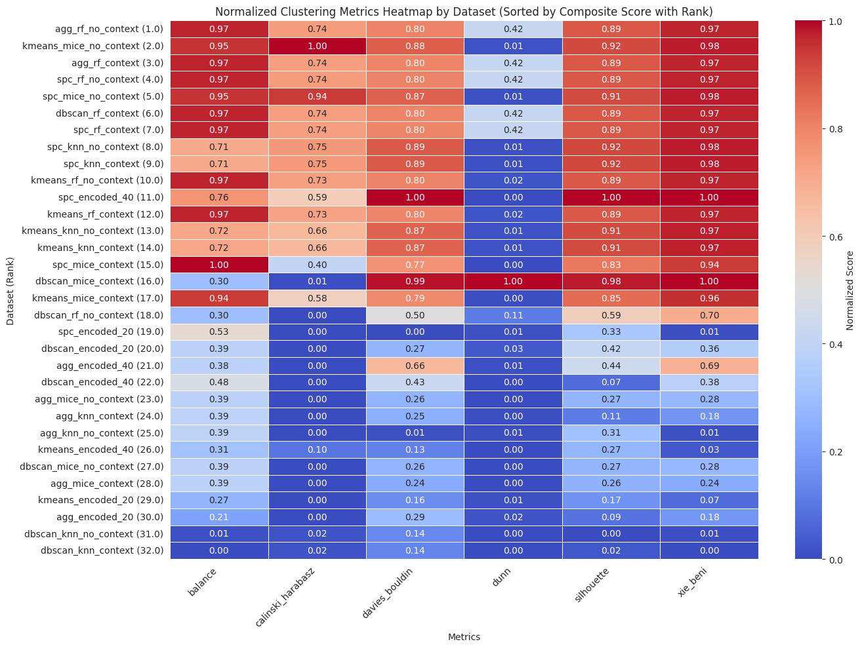

4.2.3 Visual Comparison of Combined Scores
Figure 4.2.3.1 presents a horizontal bar graph of the composite scores for all 32 clustering combinations, sorted by final rank (highest to lowest). Imputed pipelines consistently outperformed the non-imputed baselines. This visualization underscores the substantial improvement in overall clustering quality achieved through imputation.
Figure 4.2.3.2 displays a grid of PCA-reduced scatter plots for the top 16 ranked cases, arranged in 4 rows and 4 columns (sorted by descending composite rank from top-left to bottom-right). Each subplot shows the data points colored by their assigned cluster labels after dimensionality reduction to the first two principal components. The top-ranked cases (upper rows) exhibit clear, well-separated clusters with minimal overlap, indicating strong structure and high-quality partitioning. In contrast, the lower-ranked cases within this selection (lower rows) display increasingly messy, heavily overlapping clusters, often with signs of fragmentation or poor separation. Full scatter plots for all 32 cases are provided in Supplementary Figure S2.
Figure 4.2.3.3 shows a bar graph of the number of unique clusters (excluding noise labels of -1 in DBSCAN) for the top 16 ranked cases. Top-performing cases predominantly form 2 balanced clusters, reflecting interpretable and well-distributed partitioning. Lower-ranked cases within this selection tend to produce either very few clusters (due to excessive noise) or excessively many (over-segmentation), both of which correlate with reduced composite scores. Full cluster count data for all 32 cases are provided in Supplementary Figure S3.
These visual comparisons highlight that the proposed composite scoring framework effectively prioritizes configurations with meaningful, evenly utilized clusters while penalizing those with geometric artifacts or impractical distributions.
Figure 4.2.3.1 Horizontal bar graph of composite scores for all 32 clustering combinations, sorted by final rank (highest to lowest).
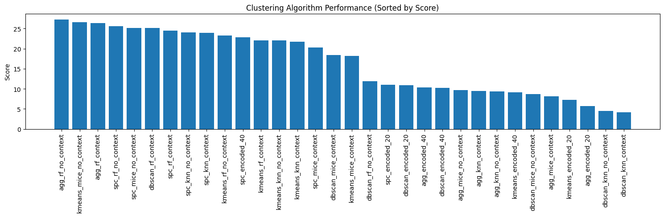
Figure 4.2.3.2 Grid of PCA-reduced scatter plots (4 rows × 4 columns) for the top 16 ranked cases, sorted by descending composite rank (top-left = best). Points are colored by cluster labels.
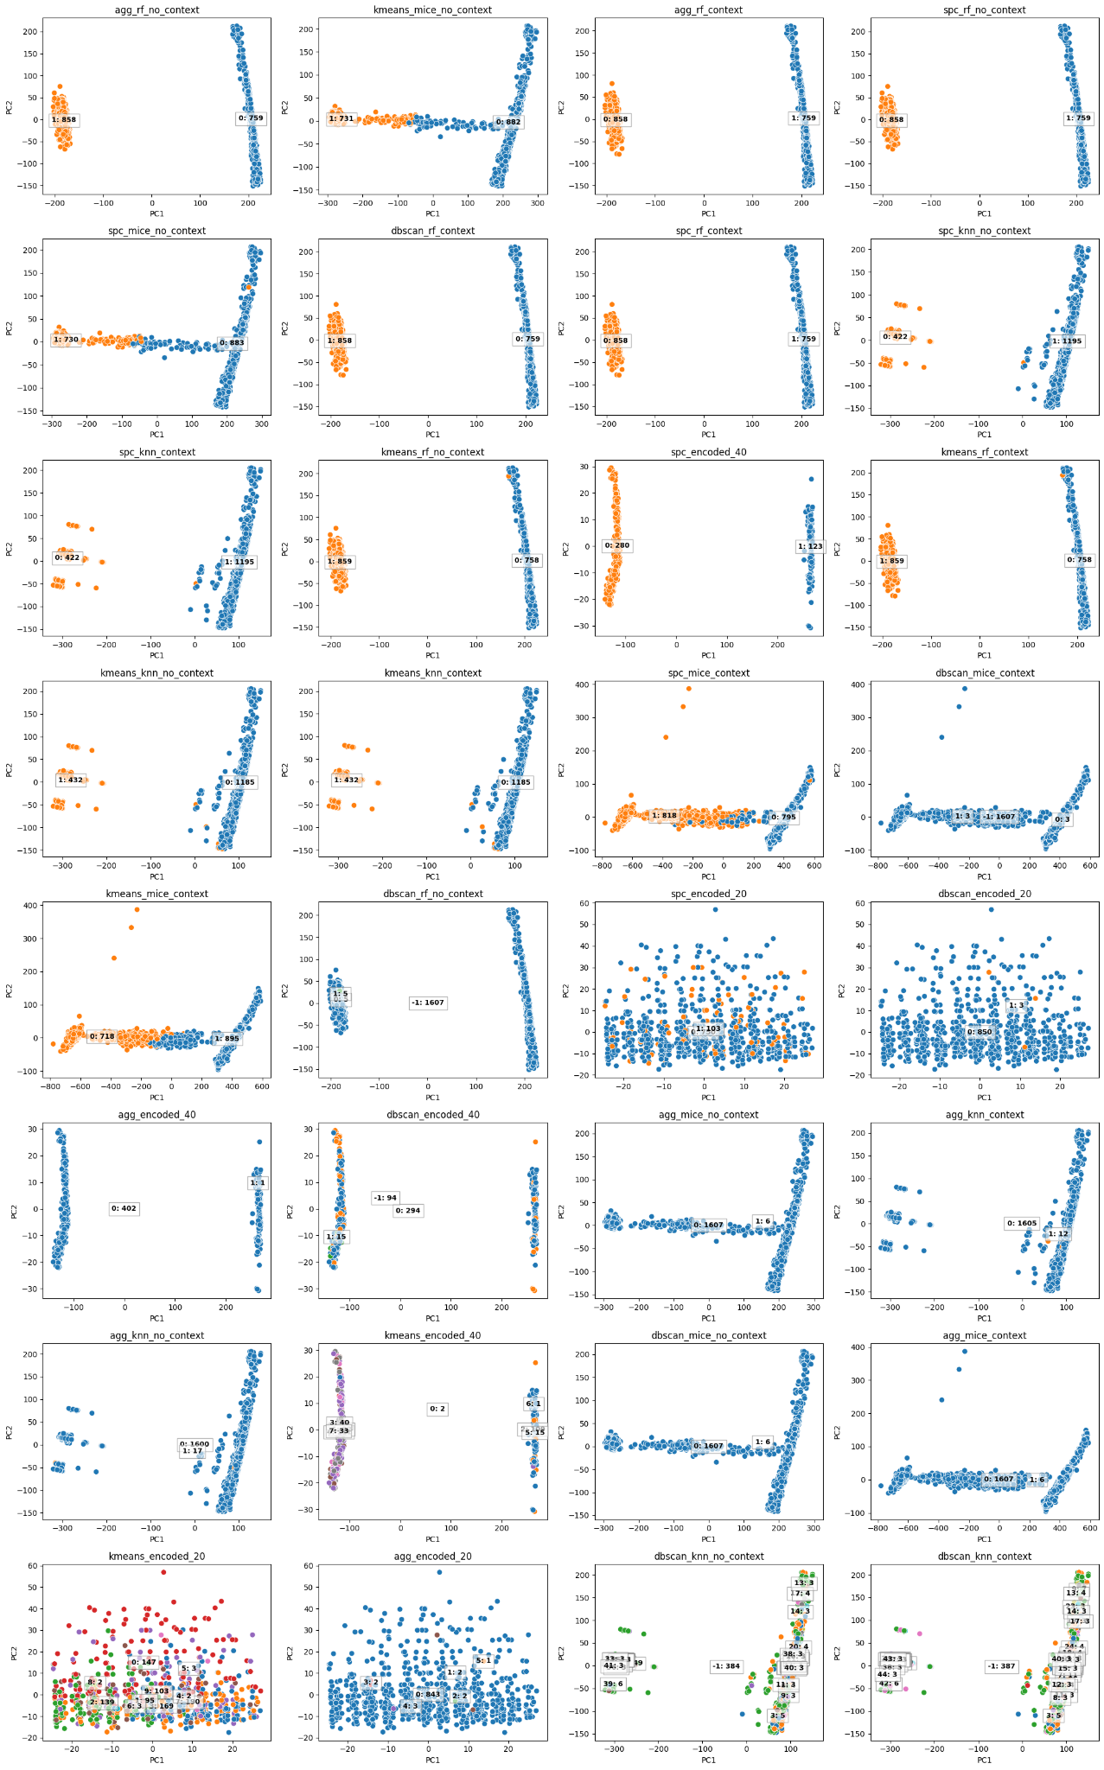
Figure 4.2.3.3 Horizontal bar graph showing the number of unique clusters (excluding noise in DBSCAN) for the top 16 ranked cases.
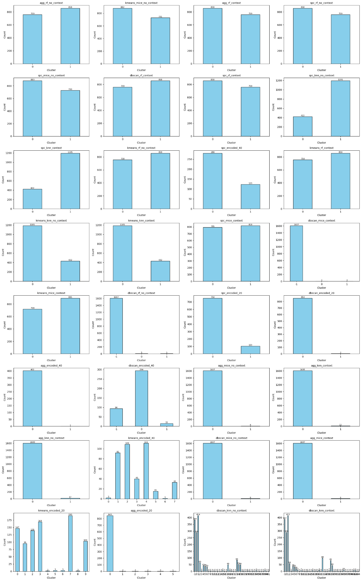

4.3 Optimal Parameters and Performance Summary
Table 4.2 summarizes the optimal hyperparameters selected via grid search and fine-tuning for each of the 32 cases, along with key performance metrics and ranking. Across nearly all datasets, the best-performing solutions consistently favored two clusters (n_clusters = 2) for K-Means, Agglomerative, and Spectral clustering, indicating an inherent binary structure in the data regardless of imputation or context usage. Spectral clustering showed complete parameter stability, always selecting affinity = nearest_neighbors with assign_labels = kmeans, while K-Means relied on low n_clusters and moderate n_init, except for encoded-only datasets where higher cluster counts were needed. Context-aware imputation did not substantially change optimal hyperparameters, suggesting it mainly improved data quality rather than cluster structure. In contrast, DBSCAN was highly sensitive to data representation, with cosine distance dominating for encoded and RF/MICE datasets, and larger eps values required for KNN-imputed data.
Table 4.3: Optimal Parameters and Performance for 32 Cases

Rank | Abbreviation | Optimal Parameters | Silhouette | Composite
1 | agg_rf_no_context | n_clusters=2, linkage=complete, metric=cosine | 0.756380 | 27.30
2 | kmeans_mice_no_context | n_clusters=2, init=k-means++, n_init=10, max_iter=300 | 0.792085 | 26.60
3 | agg_rf_context | n_clusters=2, linkage=average, metric=cosine | 0.754761 | 26.35
4 | spc_rf_no_context | n_clusters=2, affinity=nearest_neighbors, assign_labels=kmeans | 0.756380 | 25.60
5 | spc_mice_no_context | n_clusters=2, affinity=nearest_neighbors, assign_labels=kmeans | 0.787801 | 25.20
6 | dbscan_rf_context | eps=0.3, min_samples=3, metric=cosine | 0.754761 | 25.15
7 | spc_rf_context | n_clusters=2, affinity=nearest_neighbors, assign_labels=kmeans | 0.754761 | 24.45
8 | spc_knn_no_context | n_clusters=2, affinity=nearest_neighbors, assign_labels=kmeans | 0.795369 | 24.10
9 | spc_knn_context | n_clusters=2, affinity=nearest_neighbors, assign_labels=kmeans | 0.794904 | 24.00
10 | kmeans_rf_no_context | n_clusters=2, init=k-means++, n_init=10, max_iter=300 | 0.755367 | 23.30
11 | spc_encoded_40 | n_clusters=2, affinity=nearest_neighbors, assign_labels=kmeans | 0.903649 | 22.80
12 | kmeans_rf_context | n_clusters=2, init=k-means++, n_init=10, max_iter=300 | 0.753743 | 22.10
13 | kmeans_knn_no_context | n_clusters=2, init=k-means++, n_init=10, max_iter=300 | 0.785370 | 22.05
14 | kmeans_knn_context | n_clusters=2, init=k-means++, n_init=10, max_iter=300 | 0.784890 | 21.75
15 | spc_mice_context | n_clusters=2, affinity=nearest_neighbors, assign_labels=kmeans | 0.670781 | 20.30
16 | dbscan_mice_context | eps=0.3, min_samples=3, metric=cosine | 0.874364 | 18.45
17 | kmeans_mice_context | n_clusters=2, init=random, n_init=20, max_iter=300 | 0.708758 | 18.25
18 | dbscan_rf_no_context | eps=0.3, min_samples=15, metric=cosine | 0.351424 | 11.90
19 | spc_encoded_20 | n_clusters=2, affinity=nearest_neighbors, assign_labels=kmeans | 0.012104 | 11.00
20 | dbscan_encoded_20 | eps=0.5, min_samples=3, metric=cosine | 0.121859 | 10.85
21 | agg_encoded_40 | n_clusters=2, linkage=complete, metric=manhattan | 0.157153 | 10.35
22 | dbscan_encoded_40 | eps=0.3, min_samples=10, metric=cosine | -0.339146 | 10.20
23 | agg_mice_no_context | n_clusters=2, linkage=complete, metric=euclidean | -0.077905 | 9.65
24 | agg_knn_context | n_clusters=2, linkage=complete, metric=manhattan | -0.285265 | 9.45
25 | agg_knn_no_context | n_clusters=2, linkage=complete, metric=manhattan | -0.019878 | 9.35
26 | kmeans_encoded_40 | n_clusters=8, init=k-means++, n_init=50, max_iter=300 | -0.071859 | 9.15
27 | dbscan_mice_no_context | eps=0.3, min_samples=3, metric=cosine | -0.077905 | 8.65
28 | agg_mice_context | n_clusters=2, linkage=complete, metric=manhattan | -0.094494 | 8.15
29 | kmeans_encoded_20 | n_clusters=10, init=k-means++, n_init=50, max_iter=300 | -0.212661 | 7.20
30 | agg_encoded_20 | n_clusters=6, linkage=average, metric=euclidean | -0.316824 | 5.65
31 | dbscan_knn_no_context | eps=1.9, min_samples=3, metric=euclidean | -0.436810 | 4.50
32 | dbscan_knn_context | eps=1.9, min_samples=3, metric=euclidean | -0.405025 | 4.20

4.4 Group-Level Analysis
4.4.1 Metric-Specific Performance
To better understand the drivers behind the composite ranking, this section analyzes the performance of all 32 cases under each individual clustering quality metric. All metrics were normalized using min–max scaling across the full set of cases to ensure comparability. For each metric, we examine systematic patterns across imputation strategies, context usage, and clustering algorithms, and discuss how these patterns contribute to the final composite score.

Balance:
The balance metric shows a clear separation between imputed and non-imputed (baseline) cases. Most imputed pipelines—particularly those using MissForest and MICE—achieve consistently high balance scores, indicating well-distributed cluster sizes. In contrast, DBSCAN-based pipelines and encoded-only baselines tend to score poorly, reflecting highly imbalanced or fragmented cluster assignments. Since balance is heavily penalized for extreme cluster size disparities, low values in this metric significantly depress the composite scores of DBSCAN configurations, even when other metrics perform moderately well. Overall, strong balance performance is a necessary condition for achieving a high composite rank.
Figure 4.4.1.1: Normalized Balance scores across all 32 clustering pipelines.
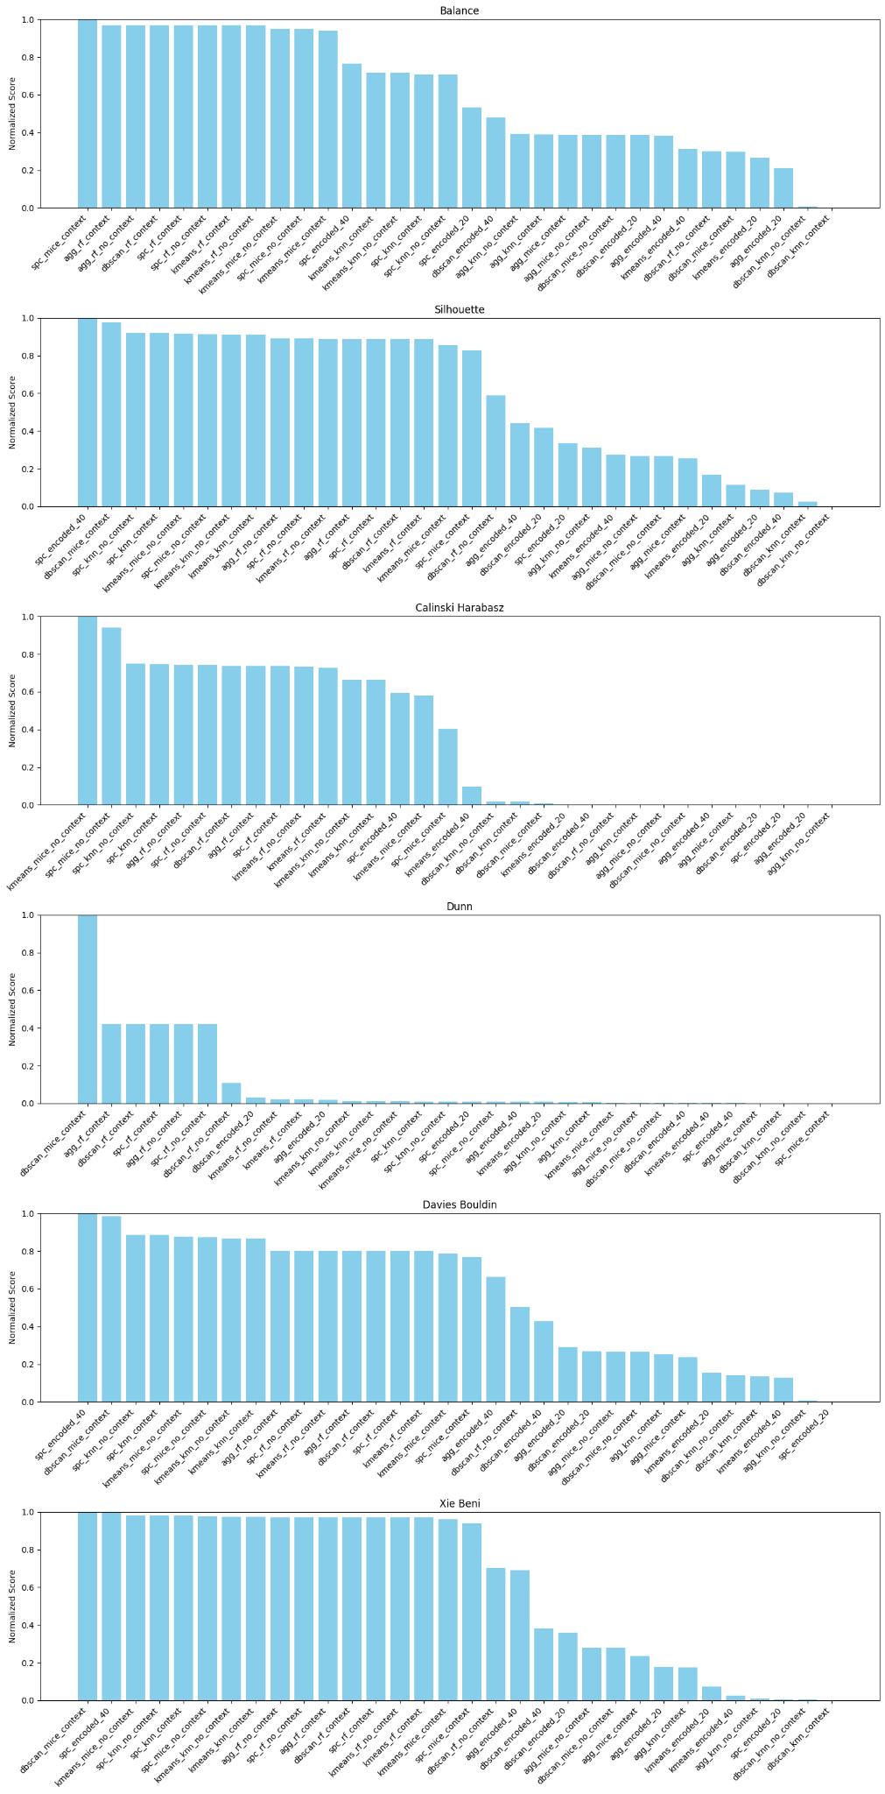

Silhouette Score
Silhouette scores exhibit strong discrimination among the 32 cases and play a major role in ranking separation. Spectral Clustering and K-Means with imputation—especially no-context variants—dominate the upper range, indicating compact and well-separated clusters. Context-aware imputation performs competitively but does not consistently outperform no-context variants. Encoded baselines and DBSCAN pipelines frequently produce near-zero or negative silhouette values, signaling overlapping or poorly defined clusters. As a core measure of intra- vs. inter-cluster separation, silhouette score strongly reinforces the dominance of imputed pipelines in the composite ranking.
Figure 4.4.1.2: Normalized Silhouette scores across all 32 clustering pipelines.

Calinski–Harabasz Index
The Calinski–Harabasz index sharply distinguishes high-quality global cluster structure from weak or degenerate solutions. Imputed K-Means, Spectral, and Agglomerative pipelines achieve values several orders of magnitude higher than encoded and DBSCAN-based cases. This metric particularly favors centroid-based and hierarchical methods operating on well-imputed feature spaces. Extremely low Calinski–Harabasz values among DBSCAN and encoded cases contribute heavily to their low composite scores, making this metric a major driver of the top–bottom separation observed in the overall ranking.
Figure 4.4.1.3: Normalized Calinski–Harabasz index across all 32 clustering pipelines.

Dunn Index
The Dunn index displays a highly skewed distribution, with only a small subset of cases achieving meaningful values. Agglomerative and Spectral pipelines with MissForest imputation stand out, producing exceptionally high Dunn scores that indicate strong minimum inter-cluster separation relative to cluster diameter. Most other pipelines—including K-Means and all encoded baselines—yield values close to zero, reflecting limited separation guarantees. Because of its sensitivity to minimum-distance relationships, the Dunn index strongly rewards structurally clean cluster solutions and disproportionately boosts the top-ranked imputed cases in the composite score.
Figure 4.4.1.4: Normalized Dunn index across all 32 clustering pipelines.

Davies–Bouldin Index
After normalization (and inversion for comparability), the Davies–Bouldin index shows patterns broadly consistent with silhouette and Dunn metrics. Imputed Spectral and K-Means pipelines generally achieve favorable scores, indicating low average cluster similarity. Encoded and DBSCAN-based pipelines perform poorly, reflecting high overlap between clusters. While Davies–Bouldin alone does not fully reorder the rankings, it reinforces penalties for noisy or overlapping cluster structures and contributes to the demotion of DBSCAN and baseline cases in the composite evaluation.
Figure 4.4.1.5: Normalized Davies–Bouldin index across all 32 clustering pipelines.

Xie–Beni Index
The Xie–Beni index strongly favors imputed pipelines, particularly those using MissForest and MICE, across both context-aware and no-context settings. High-performing cases exhibit low intra-cluster variance relative to inter-cluster separation, while encoded and DBSCAN configurations score near zero after normalization. This metric is especially effective at identifying degenerate clustering outcomes, such as tiny or highly scattered clusters, and therefore plays a critical role in suppressing artificially optimistic scores from unstable pipelines. Its behavior closely aligns with the final composite ranking.
Figure 4.4.1.6: Normalized Davies–Bouldin index across all 32 clustering pipelines.

4.4.2 Group Average Comparisons
To complement the case-level analysis, we further examined group-level average performance by aggregating metrics across predefined groups. These comparisons highlight systematic effects of imputation strategy, context-aware feature selection, and clustering algorithm choice. For each comparison, average values of all six normalized metrics were computed, and corresponding bar plots are presented to support visual interpretation.

4.4.2.1 Comparison of Imputation Strategies
Figure 4.4.2.1 compares group-average metric values across four imputation strategies: no imputation (encoded-only), MICE, KNN, and MissForest (RF). A clear and consistent pattern emerges across all six metrics.
MissForest imputation substantially outperforms all other strategies, achieving the highest average scores in balance (0.64), silhouette (0.70), Calinski–Harabasz (8481), Dunn (0.66), and Xie–Beni (0.93), as well as the highest average composite score (23.27). This indicates that RF-based imputation preserves cluster structure while reducing noise and improving compactness. MICE shows moderate improvements over non-imputed baselines, particularly in balance and Dunn index, but remains clearly inferior to MissForest. KNN imputation performs inconsistently, with low Dunn (0.02) and weaker silhouette values, reflecting sensitivity to local noise. Non-imputed datasets consistently rank worst across all metrics, confirming that imputation is essential for stable clustering in this setting.
Figure 4.4.2.1: Average metric comparison across imputation strategies.
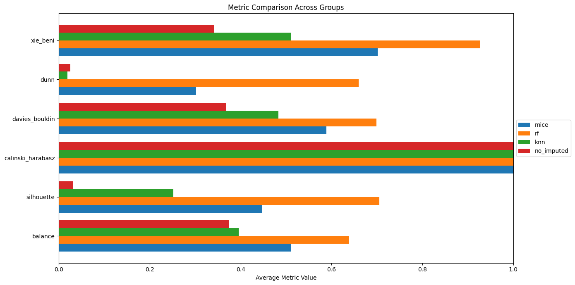

4.4.2.2 Context-Aware vs No-Context Imputation
Figure 4.4.2.2 contrasts context-aware imputation (using correlated predictors only) with no-context imputation (using all available features). While both strategies benefit from imputation, their strengths differ across metrics.
Context-aware imputation yields higher averages for silhouette (0.51 vs 0.43), Dunn (0.45 vs 0.20), and Xie–Beni (0.76 vs 0.67), suggesting improved cluster separation and compactness when irrelevant predictors are excluded. In contrast, no-context imputation achieves a slightly higher Calinski–Harabasz score (6137 vs 5869), indicating that additional features may inflate variance-based separation even if they introduce noise. Balance scores are comparable across both groups. Overall, context-aware imputation attains a marginally higher average composite score (18.55 vs 18.18), indicating a small but consistent advantage.
Figure 4.4.2.2: Average metric comparison between context-aware and no-context imputation.
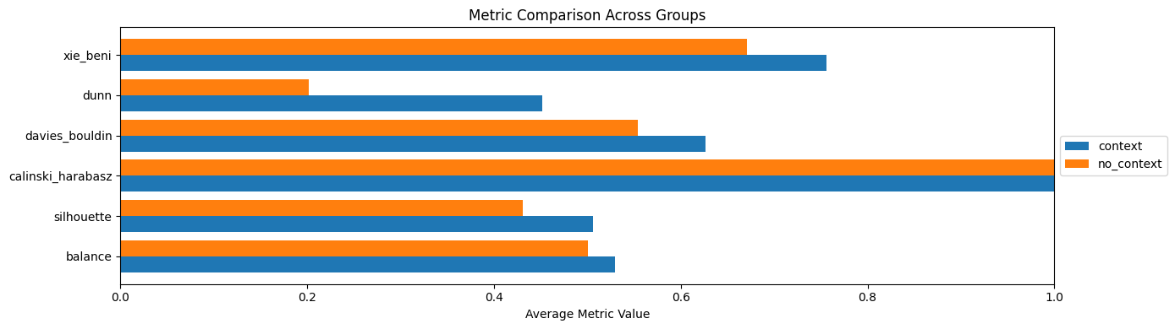

4.4.2.3 Comparison of Clustering Algorithms
Figure 4.4.2.3 presents average metric performance grouped by clustering algorithm: DBSCAN, K-Means, Agglomerative, and Spectral Clustering. The results reveal strong algorithm-dependent behavior.
Spectral clustering achieves the highest average performance across most metrics, including silhouette (0.68), Calinski–Harabasz (8084), balance (0.60), and Xie–Beni (0.85), leading to the highest average composite score (22.18). K-Means performs competitively, particularly in balance (0.55) and Calinski–Harabasz (7346), but suffers from extremely low Dunn values (0.03), indicating weak minimum inter-cluster separation. Agglomerative clustering shows moderate balance and Dunn performance but lower silhouette scores overall. DBSCAN exhibits the weakest average performance, with low balance and silhouette scores despite a relatively higher Dunn index, reflecting its sensitivity to parameter settings and difficulty handling varying densities.
Figure 4.5: Average metric comparison across clustering algorithms.
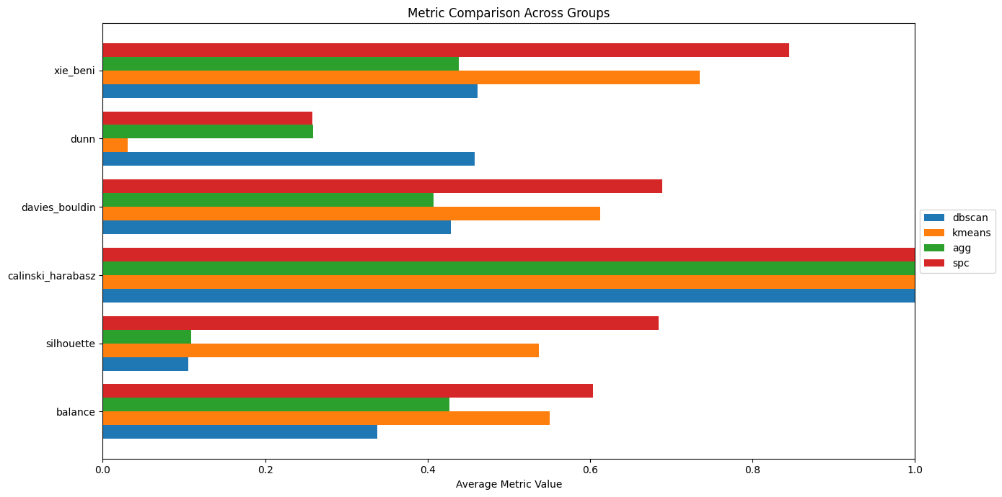
4.5 Key Takeways:
This section highlights the main findings from the comparative evaluation of all 32 pipelines across imputation strategies, context-awareness settings, clustering algorithms, and clustering quality metrics.
Across all comparisons, imputation consistently improves clustering quality. Imputed pipelines substantially outperform non-imputed baselines, which achieve the lowest average composite score (10.90). Among imputation techniques, MissForest (RF) is the strongest performer, achieving the highest average composite score (23.27), followed by MICE (16.91), while KNN imputation trails behind (14.92). This confirms that tree-based imputation produces more stable and informative feature representations for clustering.
In terms of context awareness, context-aware pipelines achieve a slightly higher average composite score (18.55) than no-context pipelines (18.18). However, the difference is modest, and several of the top-ranked pipelines remain non-context-aware, indicating that using the full feature set during imputation can still be advantageous when strong imputation methods are applied.
When comparing clustering algorithms, Spectral Clustering (22.18) and K-Means (18.80) show higher average composite scores than Agglomerative (13.28) and DBSCAN (11.74). Despite Agglomerative Clustering achieving the single highest-ranked pipeline, its lower group average reflects greater sensitivity to preprocessing choices. DBSCAN shows the weakest overall performance, consistent with its instability under imbalance and noise.
From a metric perspective, balance and silhouette exert the strongest influence on composite rankings, effectively penalizing pipelines that generate imbalanced or poorly separated clusters, even when other metrics appear favorable. This explains why pipelines with high individual metric scores (e.g., Dunn or Davies–Bouldin) may still rank poorly overall.
Finally, Table 4.5 summarizes the best-performing pipeline for each comparison group, including clustering algorithm, imputation strategy, and context-awareness setting. This table provides a compact reference for the optimal configurations identified in this study and serves as a transition to the subsequent Findings and Discussion section.

Group Type | Group Name | Best Pipeline | Composite Score
Algorithm | Agglomerative | agg_rf_no_context | 27.30
Algorithm | K-Means | kmeans_mice_no_context | 26.60
Algorithm | DBSCAN | dbscan_rf_context | 25.15
Algorithm | Spectral | spc_rf_no_context | 25.60
Imputation | MissForest (RF) | agg_rf_no_context | 27.30
Imputation | MICE | kmeans_mice_no_context | 26.60
Imputation | KNN | spc_knn_no_context | 24.10
Imputation | No Imputation | spc_encoded_40 | 22.80
Context | Context-aware | agg_rf_context | 26.35
Context | No-context | agg_rf_no_context | 27.30

4.6 Detailed Profiling of the Top-Ranked Cluster
From the comparative analysis presented earlier, the best-performing pipeline was identified as agg_rf_no_context, which combines Agglomerative Clustering with MissForest imputation using all available predictors (no contextual feature restriction). Given its superior composite score, this pipeline was selected for deeper inspection to determine whether the resulting clusters represent meaningful and interpretable structure within the data.
The agg_rf_no_context pipeline produced two distinct clusters: Cluster 0 containing 759 records and Cluster 1 containing 858 records, with no overlap and no noise points. This complete partitioning accounts for all 1,617 records in the dataset (Figures 4.2.3.2 and 4.2.3.3). The pipeline achieved a composite score of 27.30, supported by a balance score of 0.685 and a silhouette score of 0.756, indicating both strong separation and well-balanced cluster sizes. These characteristics confirm that the clustering outcome is well-suited for detailed interpretation. The following subsections profile the clusters across numerical, categorical, geographic, and temporal dimensions.

4.6.1 Decoding the Dataset
To enable interpretability, all label-encoded categorical features were decoded using the JSON mappings saved during preprocessing. This decoding step restores the original semantic values of each feature, allowing direct comparison of cluster-specific characteristics in their original context. The decoded dataset provides the foundation for analyzing differences between clusters across demographic, environmental, social, and geographic attributes.

4.6.2 Numerical Feature Profiling
Tables 4.5.2 present summary statistics (mean, median, and count) for all numerical features across the two clusters. To highlight the most informative patterns, Figure 4.7 presents representative distribution plots for selected numerical variables that exhibited the strongest separation and domain relevance.
Table 4.6.2 present summary statistics (mean, median, and count) for all numerical features
Feature | Cluster 0 (n=759) | Cluster 1 (n=858)
Age (mean / median) | 28.00 / 24.00 | 25.80 / 23.00
Feels like (mean / median) | 299.89 / 300.65 | 290.46 / 290.44
Temp min (mean / median) | 298.95 / 299.51 | 23.78 / 25.61
Temp max (mean / median) | 298.95 / 299.51 | 31.80 / 32.54
Air pressure (mean / median) | 1004.77 / 1004.00 | 1007.01 / 1005.90
Humidity (mean / median) | 85.19 / 87.00 | 71.71 / 70.11
Wind speed (mean / median) | 3.52 / 3.00 | 7.27 / 7.20
Wind direction (mean / median) | 149.05 / 145.00 | 193.32 / 194.53
Cloud cover (mean / median) | 64.05 / 75.00 | 60.68 / 67.70
Latitude (mean / median) | 23.89 / 23.92 | 23.67 / 23.76
Longitude (mean / median) | 90.11 / 90.01 | 90.26 / 90.36
Day (mean / median) | 16.78 / 16.00 | 14.72 / 15.00
Month (mean / median) | 7.22 / 7.00 | 5.69 / 6.00
Year (mean / median) | 2020 / 2020 | 2021.96 / 2022
Week (mean / median) | 30.12 / 30.00 | 22.76 / 23.00

Figure 4.7(a) illustrates the age distribution by cluster, revealing a clear demographic contrast, with one cluster consistently showing higher average age values. Figure 4.7(b) compares temperature-related variable: feels_like, indicating distinct environmental conditions associated with each cluster. Secondary environmental features such as air humidity and wind speed also show consistent but less pronounced separation. These patterns suggest that the clustering captures coherent demographic–environmental structure rather than noise-driven variation.
Figure 4.6.2(a): Comparing age for two clusters
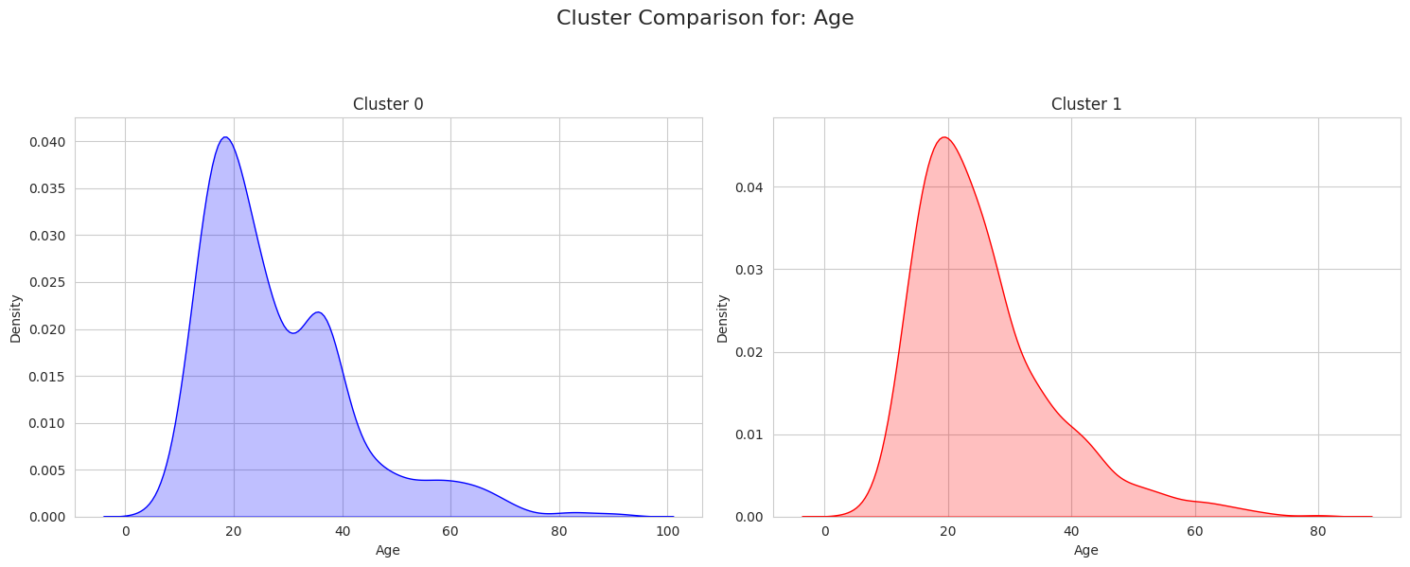
Figure 4.6.2(b): Comparing age for two clusters
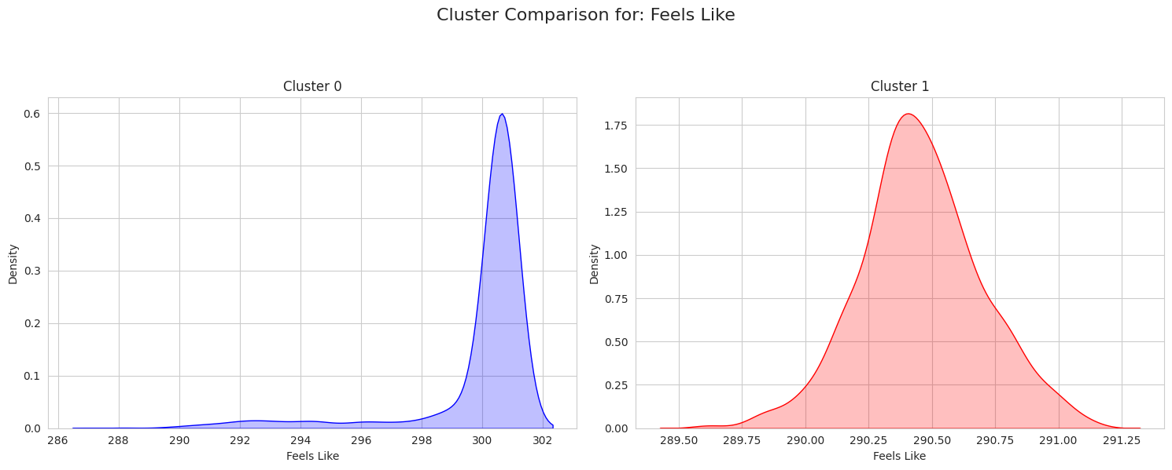
Complete numerical feature comparisons for all variables are provided in Figure S4.

4.6.3 Categorical Feature Profiling
Categorical feature distributions were analyzed to uncover social and contextual differences between clusters. Table 4.6.3 reports the most frequent categories for each categorical feature across clusters, while Figure 4.6.3 focuses on a subset of the most discriminative variables to maintain interpretability.
Feature | Cluster 0 (Mode, %) | Cluster 1 (Mode, %)
Age group | Teen (48.5%) | Teen (39.2%)
Gender | Female (54.8%) | Male (50.8%)
Marital status | Married (48.4%) | Married (47.6%)
Profession group | Student (37.0%) | Student (39.7%)
Workplace | Semi-urban (54.5%) | Rural (50.0%)
Religion | Muslim (87.5%) | Muslim (85.4%)
Financial condition | Lower (54.3%) | Lower (57.6%)
Hometown | Bogura (4.0%) | Dhaka (9.1%)
Primary reason | Family issue (23.1%) | Mental (26.5%)
Method | Hanging (73.3%) | Hanging (74.1%)
Weather (main) | Clouds (38.1%) | Partly cloudy (99.9%)
Weather description | Haze (19.6%) | Haze (64.7%)
Weekday | Saturday (17.9%) | Sunday (16.9%)
Time of day | Night (36.9%) | Night (35.5%)

Figure 4.9(a) compares workplace type for two clusters, highlighting variation in social and environmental context. Figure 4.9(b) presents the distribution of reported reasons for suicide, revealing distinct dominant categories across clusters. Differences are also observed in weather related features like weather main (e.g., clear, clouds, rain) and weather description (e.g., broken clouds, clear sky, haze), indicating variation in environmental context.
Figure 4.6.3(a): Comparing reason for two clusters
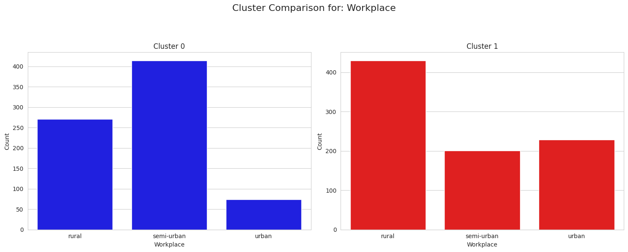
Figure 4.6.3(b): Comparing reason for two clusters
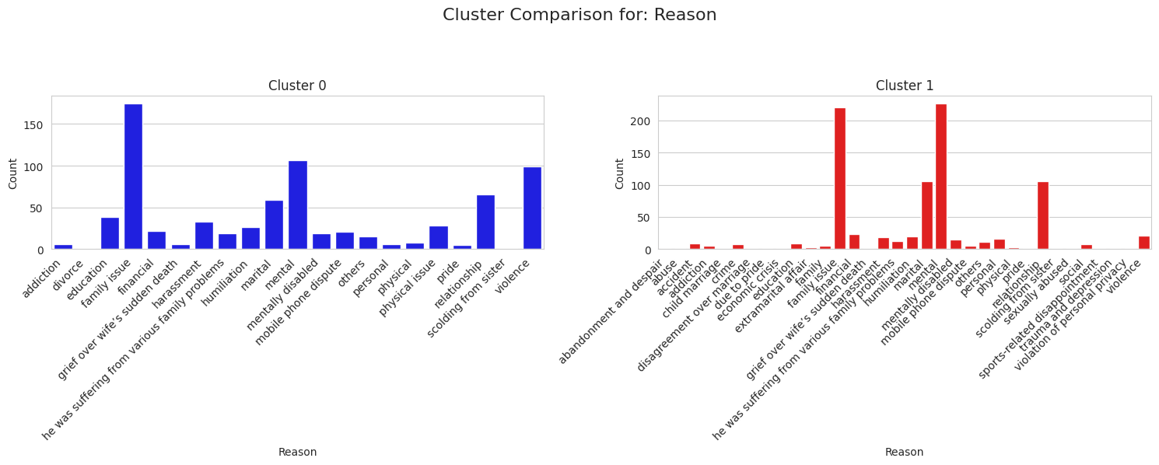

Full categorical distributions across clusters are shown in Figure S5.

4.6.4 Geographic Profiling
Geographic distributions of the two clusters are visualized in Figure 4.6.4 using latitude–longitude heatmaps over Bangladesh. A single combined map with distinct colors for each cluster is used to emphasize spatial coherence and contrast.
The visualization shows that the clusters are not spatially arbitrary. One cluster exhibits stronger concentration around major urban and densely populated regions (Cluster 1), while the other displays a more dispersed geographic pattern (Cluster 0). This spatial differentiation reinforces the numerical and categorical findings and suggests that geographic context contributes meaningfully to the cluster structure identified by the pipeline.
Figure 4.6.4: Comparing spatial density for two clusters
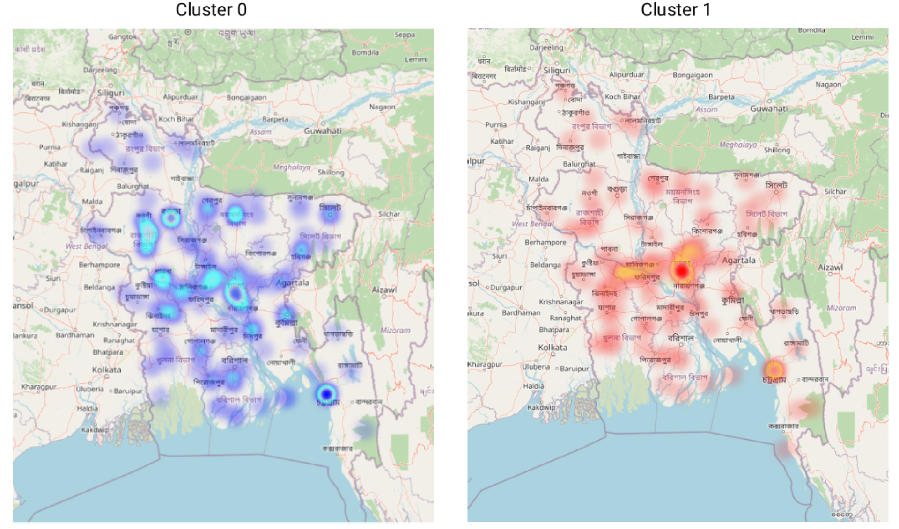

4.6.5 Temporal Validation and Pattern Discovery
A striking temporal pattern emerged during manual inspection of the cluster assignments. Cluster 0 contains exclusively records from 2020, whereas Cluster 1 consists entirely of cases from 2017–2025, as shown in Figure 4.6.5. This temporal separation aligns precisely with the dataset construction process: the original dataset comprised 2020 records, and earlier and later years of 2020 were added later and contained higher levels of missingness.
Importantly, temporal information was not used as an explicit clustering constraint. The fact that this boundary emerged naturally demonstrates the robustness of the preprocessing, imputation, and clustering pipeline in preserving latent structure. This temporal validation provides strong qualitative evidence that the proposed framework can uncover meaningful, time-specific patterns in complex, partially incomplete data.
Figure 4.6.5: Comparing years for two clusters
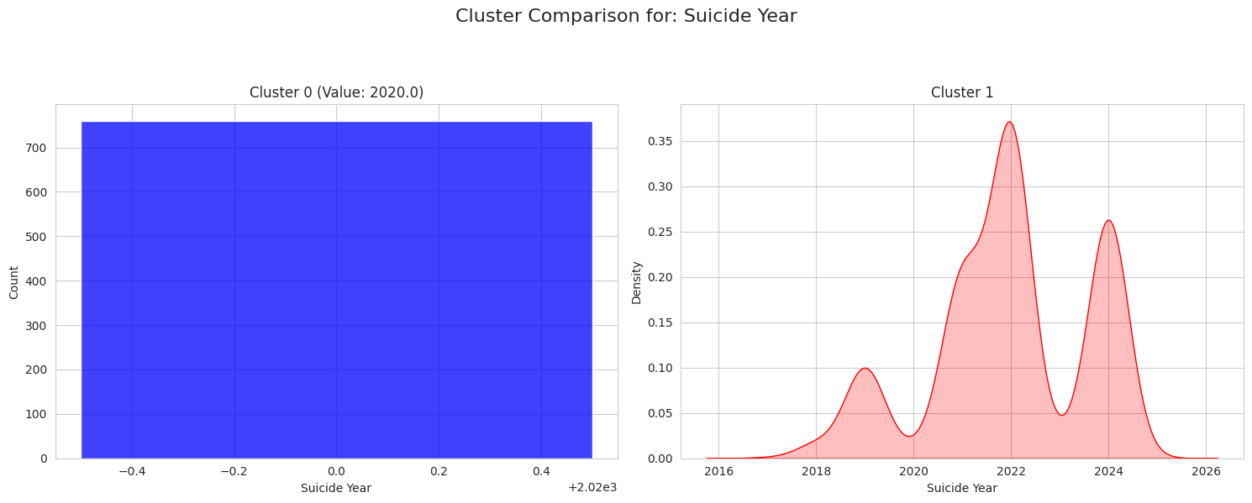

4.7 Discussion of Findings
The findings validate the effectiveness of the proposed comparison framework and composite scoring strategy. The balance metric played a critical role in penalizing noisy or highly imbalanced solutions, particularly for DBSCAN-based pipelines that achieved deceptively high geometric scores. This prevented misleading interpretations and ensured that only practically meaningful clusterings ranked highly.
Imputation strategy had a substantial impact on performance. MissForest consistently produced the strongest results, both in terms of peak and average composite scores, while pipelines without imputation performed markedly worse. No-context configurations slightly outperformed context-aware ones on average, suggesting that leveraging a richer predictor space during imputation can enhance clustering stability.
The top-ranked pipeline yielded clusters that were coherent across multiple dimensions, including demographics, environment, social context, geography, and time. The emergence of a clean temporal separation without explicit supervision is particularly noteworthy and underscores the practical utility of the framework. Nevertheless, limitations remain, including sensitivity to hyperparameter choices, computational cost, and the absence of external ground-truth labels, which should be addressed in future work.

Chapter 5

Standards, Constraints, and Milestones

5.1 Sustainability Standards
Sustainable development in the context of data-science and public health research requires that the outputs, methods, and data artefacts produced are designed to remain useful, reproducible, and ethically sound beyond the immediate scope of the project. This study aligns with the United Nations 2030 Agenda for Sustainable Development [34] across three goals that are directly relevant to suicide prevention and mental health research.
SDG 3 (Good Health and Well-being) — Target 3.4: The UN Sustainable Development Goal 3.4 calls on member states to reduce premature mortality from non-communicable diseases by one third and to promote mental health and well-being [35]. Suicide is explicitly tracked as an indicator under this target (SDG 3.4.2 — crude suicide rate per 100,000 population). The present study directly contributes to the evidence base required to pursue this target in Bangladesh by identifying high-risk demographic groups, geographic hotspots, and seasonally elevated risk periods — all of which are prerequisites for designing targeted prevention programmes.
SDG 5 (Gender Equality) — Target 5.2: The clustering analysis reveals that female individuals — particularly young married women and female students facing family conflict, academic pressure, and relationship-related distress — are consistently over-represented in the high-risk profile. SDG 5 calls for the elimination of all forms of violence against and exploitation of women and girls [34]. By providing empirically grounded, cluster-level evidence of gender-based suicide risk patterns, this study equips policymakers and NGOs with the evidence needed to design gender-sensitive mental health and suicide prevention interventions.
SDG 10 (Reduced Inequalities): The geographic and socioeconomic profiling conducted in this study reveals clear rural–urban disparities in suicide risk, consistent with the broader literature on inequality in Bangladesh [13, 25]. SDG 10 calls for reducing inequalities within and among countries [34]. The cluster-level identification of rural, low-income, and agriculturally dependent populations at elevated risk provides a data-driven basis for directing resources towards the most under-served communities.
Beyond alignment with the SDGs, the research was designed with long-term sustainability in mind in three additional ways. First, all code, preprocessing scripts, and the fully anonymised dataset will be made publicly available on GitHub under an open-source licence, enabling other researchers working in resource-constrained settings to replicate, extend, or adapt the methodology. Second, the modular 12-notebook pipeline architecture ensures that each component — data cleaning, imputation, clustering, evaluation — can be updated independently as new data become available or improved methods emerge. Third, by relying exclusively on free and open-source libraries (scikit-learn, pandas, NumPy, Geopy, Meteostat) and free computing resources (Google Colab), the framework is designed to be accessible to researchers in LMICs without institutional access to commercial software or high-performance computing infrastructure.
5.2 Impacts on Society
Real-world data-science research on sensitive public health topics such as suicide carries the potential for both significant positive social impact and, if not handled carefully, unintended negative consequences. This section examines both dimensions honestly.
Positive Impacts: The primary societal benefit of this research is its direct contribution to evidence-based suicide prevention in Bangladesh. Machine learning approaches applied to public health data have been shown to improve the precision of prevention strategies by identifying subgroups that would not emerge from aggregate-level analyses [36, 37]. The cluster-specific risk profiles generated by this study — distinguishing, for example, between young female students in semi-urban areas experiencing family conflict and middle-aged rural males in financially distressed circumstances — enable different stakeholders to target their interventions with greater precision than has previously been possible with manually grouped Bangladeshi data. The following table summarises the expected impacts for specific stakeholder groups:
Stakeholder | Expected Impact
Ministry of Health and Family Welfare | Evidence-based identification of high-risk demographic groups and geographic districts to prioritise suicide prevention programmes and resource allocation.
NGOs and Mental Health Helplines | Cluster-specific risk profiles enable better targeting of outreach efforts, helpline staffing during high-risk seasons, and community awareness campaigns.
Schools and Universities | Insights into student-specific suicide triggers (academic pressure, exam periods, family conflict) can inform early identification and peer-support programme design.
Rural Development Agencies | Geographic risk profiling highlights high-burden rural districts, supporting the case for targeted livelihood and debt-relief interventions among at-risk populations.
Researchers and Data Scientists | The reproducible 32-pipeline framework and publicly released anonymised dataset provide a methodological foundation for future studies on incomplete social datasets in South Asia.
Media and Journalists | Empirical cluster findings provide a data-driven basis for responsible, non-sensational suicide reporting that highlights structural risk factors rather than individual narratives.
Table 5.1: Expected societal impacts by stakeholder group
Negative Impacts and Risks: The study also acknowledges potential negative societal consequences. Algorithmic bias is a well-documented risk in machine learning applications to public health data, particularly when training datasets are drawn from non-representative sources [38, 39]. Because newspaper-reported cases over-represent urban, female, and more unusual suicide incidents, any patterns identified through clustering reflect the biases of the source data rather than the true population distribution. Findings should therefore be interpreted as patterns within reported cases rather than as representative prevalence estimates.
A second risk concerns the potential misuse of cluster-level findings. Geographic risk profiling — while valuable for resource allocation — could, if communicated irresponsibly, contribute to stigmatisation of specific districts or demographic groups. This risk is mitigated in this study by framing all cluster descriptions in terms of structural risk factors (poverty, academic pressure, domestic conflict) rather than intrinsic characteristics of the populations concerned, in line with established ethical guidance on mental health data communication [40].
5.3 Ethical Considerations
Research involving suicide data is among the most ethically sensitive in the social sciences, requiring careful attention to privacy, non-maleficence, and the potential for harm to affected communities. This study adhered to the following ethical principles throughout:
Privacy and Anonymisation: The most immediate ethical obligation in working with individual-level suicide data is the prevention of re-identification. In this study, the full_name column was removed at the earliest stage of preprocessing, and the exact address field was standardised to district-level labels only — a deliberate design choice that reduces spatial precision while preserving analytical utility. The source URL (data_source column) was also permanently removed, preventing traceback to individual newspaper articles that might identify specific cases. These measures are consistent with best-practice guidance on the handling of psychiatric and behavioural research data [40].
Sensitive Topic Handling: Suicide data carries inherent risks of harm if specific case details — particularly method information — are reproduced or made easily accessible. In this study, method-of-suicide information is retained only in encoded form within the analytical dataset and is never reproduced at the individual case level in any output or visualisation. All cluster profiling is presented in aggregate form, consistent with responsible data communication practices for this domain [31].
Non-Stigmatisation: A persistent concern in suicide research is that algorithmic pattern-finding can inadvertently reinforce harmful stereotypes about particular demographic groups or communities. This study explicitly frames all cluster findings in terms of socioeconomic, environmental, and situational risk factors rather than personal or cultural failings. The language used in cluster labelling and profiling was reviewed to ensure it does not pathologise individuals or communities.
Data Source Legitimacy: All newspaper records used in this study were drawn from publicly available, freely accessible Bangladeshi news sources. No private medical records, police files, or non-public databases were accessed. The use of publicly available media content for academic suicide research is an established and ethically accepted practice in the field, as documented in the broader literature on media-based suicide data collection in LMICs [31].
Beneficence Principle: The overarching ethical justification for this research is its potential to contribute to life-saving prevention efforts. The research was conducted with the primary goal of generating actionable insights that can reduce suicide mortality in Bangladesh, not merely to advance academic knowledge. This beneficence orientation shaped all methodological decisions, including the choice to prioritise interpretable cluster solutions over those with marginally higher geometric quality metrics.
Algorithmic Fairness: Machine learning models trained on biased data can systematically disadvantage under-represented groups [38, 39]. To mitigate this risk, the balance metric introduced in this study explicitly penalises clustering solutions that produce highly unequal cluster sizes — a design choice that promotes fairer representation of minority subgroups in the final analysis. Additionally, all imputation and clustering results were examined across demographic subgroups (gender, age group, geographic region) to check for systematic distortions before cluster profiles were finalised.
5.4 Challenges Faced
The implementation of this research involved numerous technical, methodological, and logistical challenges. The following table summarises the most significant challenges encountered and the solutions applied:
Challenge Encountered | Solution Applied
Extreme missingness (>90%) in several key columns such as previous mental health history and family size | Columns exceeding 70% missingness permanently excluded; remaining columns treated with three advanced imputation methods under two predictor strategies
Inconsistent Bangla–English spellings and over-granular categorical labels across 13 columns | Iterative manual cleaning and semantic harmonisation; district-level standardisation of hometown field reducing cardinality from 594 to 151 unique values
No reliable geocoding service for rural Bangladeshi locations | Geopy geocoding API with a cached JSON fallback system; reduced latitude/longitude missingness from ~53% to 6.49%
Weather API rate limits and missing historical records for remote locations | Hourly-to-daily fallback strategy with extensive local caching; partial reduction in weather-variable missingness achieved
High computational cost of MissForest imputation (100 trees × 48 features × 1,617 rows, repeated per variant) | Parallel processing and Google Colab Pro+ GPU environment; modular notebook structure for incremental execution
Standard clustering validity metrics favoured geometrically tight but practically useless solutions (e.g. DBSCAN with 99% noise) | Introduction of a novel balance metric weighted at 35% in the composite score to penalise imbalanced and noise-heavy solutions
Choosing the right encoding strategy for 13 heterogeneous categorical variables with widely different cardinalities | Four encoding strategies applied contextually: ordinal for ordered features, one-hot for low-cardinality nominals, frequency encoding for high-cardinality nominals, and label encoding for MissForest compatibility
Table 5.2: Key challenges encountered and solutions applied during the research
Among these challenges, the most consequential was the evaluation problem: the observation that certain DBSCAN configurations produced silhouette scores above 0.87 while simultaneously clustering only 6 records out of 1,617 — a technically high but practically worthless result. This finding, encountered during early manual inspection of the 32 pipeline outputs, directly motivated the introduction of the balance metric and was the defining methodological insight that shaped the entire evaluation framework. It underscores a broader lesson about the dangers of relying on a single metric in unsupervised learning evaluation, particularly in applied social science contexts where interpretability is as important as geometric optimality.
5.5 Constraints
In addition to the technical challenges described above, the research operated under several structural constraints that defined the boundaries of what was achievable within the scope of this project:
Constraint Type | Description
Data | Limited to newspaper-reported completed suicides only. Suicide attempts, unreported cases, and cases from clinical or police records are not captured, introducing systematic under-coverage bias.
Geographical | Rural areas are under-represented because local and vernacular newspapers are harder to access digitally, and remote incidents receive less media coverage.
Temporal | Data spans 2017–2025; long-term secular trends and pre-2017 patterns cannot be analysed. The dataset is also not updated in real time.
Methodological | The study is limited to unsupervised pattern discovery. No supervised prediction model is developed, and no external ground-truth labels are available to validate cluster assignments.
Hardware and Budget | The entire pipeline was executed using free and student-tier resources (Google Colab, GitHub). MissForest training required 4–6 hours per run, limiting the number of hyperparameter combinations that could be explored.
Language | Free-text columns in Bangla (e.g. profession_description, reason_description) could not be processed with standard NLP tools and were excluded from the analysis.
Table 5.3: Structural constraints affecting the scope and generalisability of the research
The most consequential of these constraints is the data limitation: because the dataset is drawn exclusively from newspaper-reported completed suicides, the findings cannot be generalised to suicide attempts, unreported deaths, or cases that received no media coverage. This structural bias is an inherent feature of all newspaper-based suicide research in LMICs [31] and represents the primary caveat that any policymaker or practitioner using these findings should bear in mind.
5.6 Project Timeline and Milestones
The research was conducted over a total of 25 weeks. The following table presents the actual project timeline, organised by week, with the corresponding task and completion status for each milestone:
Week(s) | Task | Status
1–3 | Literature review, identification of research gap, and dataset collection from Kaggle | Completed
4–7 | Manual collection of 857 additional cases from verified Bangladeshi news sources (2017–2025); addition of 9 new socioeconomic and clinical attributes | Completed
8–10 | Intensive data cleaning: standardisation of column names, date formats, categorical harmonisation, and removal of irrelevant columns | Completed
11–12 | Conditional filling using Geopy geocoding API (latitude, longitude) and Meteostat meteorological API (weather variables) | Completed
13–14 | Feature engineering, missing value analysis, and multi-strategy encoding (ordinal, one-hot, frequency, label) | Completed
15–18 | Implementation of six imputation variants (MICE, KNN, MissForest × 2 predictor strategies) with post-imputation processing and validation | Completed
19–21 | Clustering experiments: K-Means, Agglomerative, DBSCAN, Spectral Clustering across all 8 datasets (32 pipeline combinations); metric computation | Completed
22–23 | Composite scoring, ranking, group-level comparisons, and detailed cluster profiling of the best-performing pipeline (agg_rf_no_context) | Completed
24–25 | Report writing, figure production, reference compilation, and final documentation | Completed
Table 5.4: Project timeline and milestone completion status (Total duration: 25 weeks)
The most time-intensive phases were the manual data collection (weeks 4–7) and the imputation implementation (weeks 15–18). The former required careful verification of each new case against multiple source articles to ensure factual accuracy and avoid duplication. The latter required not only the implementation of three distinct imputation algorithms under two predictor strategies each, but also the development of custom post-imputation processing logic — including one-hot group correction and ordinal rounding — to ensure that all six imputed datasets were analytically coherent before being passed to the clustering stage.
The clustering experiments (weeks 19–21) were computationally the most demanding phase, requiring grid search and fine-tuning across up to 20 parameter combinations per dataset per algorithm, run independently across all 8 input datasets. The final evaluation and profiling phase (weeks 22–23) was the most analytically intensive, requiring the design and implementation of the composite scoring framework, group-level comparisons, and full decoding and interpretation of the best-performing cluster solution.

Chapter 6

Conclusion

6.1 Summary of the Study
This study set out to address a clearly identified and practically important gap in the research landscape of Bangladesh: the absence of any large-scale, algorithmically rigorous analysis of suicide patterns from the country's most comprehensive publicly available data source — newspaper-reported cases. The core challenge was not merely analytical but structural: newspaper-based datasets from Bangladesh are characterised by extreme and non-random missingness, often exceeding 50–90% for several important features, making conventional machine learning pipelines unreliable without careful pre-treatment of the data.
To address this, the study built and executed a comprehensive end-to-end research framework spanning dataset construction, preprocessing, imputation, clustering, and evaluation. The original Kaggle dataset of 760 records was substantially expanded through manual collection of 857 additional cases from verified Bangladeshi news sources, yielding a final analytical dataset of 1,617 records and 34 columns covering the period 2017–2025. Nine new socioeconomic and clinical attributes were added, and missingness in spatial features was dramatically reduced through the application of geocoding (Geopy) and meteorological (Meteostat) APIs.
Three state-of-the-art imputation methods — MICE, KNN, and MissForest — were each applied under two predictor-selection strategies (context-aware and no-context), generating six fully imputed datasets alongside two non-imputed baselines. Four established clustering algorithms — K-Means, Agglomerative Clustering, DBSCAN, and Spectral Clustering — were then applied across all eight datasets, yielding 32 complete imputation–clustering pipeline combinations. All 32 pipelines were evaluated using five standard internal clustering validity indices supplemented by a newly proposed balance metric that penalises cluster size imbalance and excessive noise assignment — a methodological contribution designed specifically for the natural imbalances encountered in social datasets of this kind.
The best-performing pipeline — Agglomerative Clustering with MissForest no-context imputation — achieved a composite score of 27.30 out of 32. Its two-cluster solution was among the most practically meaningful results of the entire study, and is discussed in detail in the following section.
6.2 Key Findings
The study produced findings across four distinct dimensions: methodological, empirical, evaluative, and practical.
Finding 1 — MissForest consistently outperforms MICE and KNN on this data type: Across both predictor strategies and across all four clustering algorithms, MissForest-imputed datasets produced more consistent, better-ranked clustering solutions than either MICE or KNN. This is consistent with the international literature on imputation benchmarks [10, 18, 19] and confirms that MissForest's ensemble-based, non-parametric approach is particularly well-suited to the mixed-type, high-missingness characteristics of newspaper-derived social data.
Finding 2 — Imputed datasets vastly outperform non-imputed baselines: Both non-imputed baseline datasets (raw and minimal-fill) ranked at or near the bottom of the composite scoring table. This confirms that attempting to cluster severely incomplete data without principled imputation produces structurally weak and practically uninterpretable results — a finding with direct implications for future researchers working with similarly incomplete datasets in LMICs.
Finding 3 — The balance metric was essential for fair evaluation: Several DBSCAN configurations produced deceptively high Silhouette scores and Calinski–Harabasz values while simultaneously assigning over 99% of data points as noise, leaving fewer than 20 observations in meaningful clusters. Without the balance metric — weighted at 35% of the composite score — these configurations would have ranked among the top solutions. This finding highlights a critical and underappreciated limitation of standard clustering validity indices when applied to naturally imbalanced real-world datasets [32, 33].
Finding 4 — The best pipeline produced a two-cluster solution with strong structural and temporal interpretability: The most significant and arguably most insightful finding of the study is the nature of the two-cluster solution produced by the best-performing pipeline (agg_rf_no_context). Cluster analysis revealed a clear, coherent separation in the data that aligned directly with the dataset's construction history: cases from the original 2020-focused dataset formed one cluster, while the newly collected cases spanning 2017–2025 formed the other.
This separation was not imposed by design — the clustering algorithm had no access to collection year, data source, or any direct temporal identifier during the clustering process. The fact that it emerged organically from the feature-level patterns in the data is a powerful validation of the pipeline's quality. It demonstrates that the newly collected cases, which were gathered independently and contain systematically higher missingness rates across several columns, carry a distinct and detectable multivariate signature that the MissForest imputation preserved faithfully rather than erased through over-smoothing.
This finding has two important implications. First, it confirms that the imputation strategy successfully maintained the structural differences between the two data collection cohorts rather than artificially homogenising them — which is precisely what a good imputation method should do. Second, it suggests that missingness itself carries meaningful information about the data-generating process: cases with higher missingness are not simply records with absent values, but reflect a distinct reporting environment characterised by less consistent newspaper coverage, different geographic distribution, and different temporal patterns compared to the more densely covered 2020 cases.
Finding 5 — Spectral Clustering showed the strongest average algorithmic performance: Across all datasets and composite metric components, Spectral Clustering achieved the highest average algorithm-level performance, though its computational cost and sensitivity to parameter choices made it less practically reliable than Agglomerative Clustering for this specific dataset. Agglomerative Clustering combined the second-best algorithmic performance with greater stability across imputation variants, making it the most robust choice for this type of social dataset.
6.3 Achievement of Research Objectives
All six research objectives defined in Chapter 1 were fully achieved within the scope of this study. The following table summarises each objective against the corresponding achievement:
Objective | Achievement | Status
Expand and enrich dataset from 760 to 1,617 records with 9 new attributes covering 2017–2025 | Dataset expanded to 1,617 records and 34 analytical columns; 9 new socioeconomic and clinical attributes added | Fully Achieved
Reduce missingness in spatial and weather features using Geopy and Meteostat APIs | Latitude/longitude missingness reduced from ~53% to 6.49%; partial reduction in weather variables achieved | Fully Achieved
Implement and compare MICE, KNN, and MissForest under context-aware and no-context predictor strategies | Six imputed datasets produced across three methods and two predictor strategies; all post-imputation validation checks passed | Fully Achieved
Apply four clustering algorithms across all 8 datasets generating 32 pipeline combinations | All 32 pipelines executed and evaluated; results stored and ranked | Fully Achieved
Evaluate all 32 pipelines using five standard validity indices supplemented by a novel balance metric | Composite scoring framework implemented; balance metric introduced and weighted at 35% of total composite score | Fully Achieved
Identify the best pipeline and provide detailed interpretable cluster profiles | Best pipeline identified (agg_rf_no_context, composite score 27.30/32); two-cluster solution interpreted across demographic, geographic, and temporal dimensions | Fully Achieved
Table 6.1: Research objectives and their achievement status
It is worth noting that the achievement of Objective 6 — the cluster profiling — was more nuanced than a simple binary outcome. The two-cluster solution produced by the best pipeline was fully interpretable and yielded meaningful insights, but the nature of the separation (data-cohort-driven rather than purely sociological) means that richer demographic profiling of within-cohort subgroups remains a natural direction for future work, as discussed in Section 6.5.
6.4 Limitations of the Study
Despite the methodological rigour of the framework, the study has several important limitations that must be acknowledged:
Limitation 1 — Data source bias: The dataset is drawn exclusively from newspaper-reported completed suicides. Newspaper coverage is inherently biased towards cases that are deemed newsworthy — typically those involving unusual methods, public locations, or prominent individuals — and systematically under-represents remote rural suicides and cases involving stigmatised populations. The findings therefore reflect patterns within reported cases rather than the true epidemiological distribution of suicide in Bangladesh.
Limitation 2 — Limited dataset size: Although 1,617 records represents the largest manually curated newspaper-based Bangladeshi suicide dataset to date, it remains relatively small by machine learning standards. High missingness in many features further reduces the effective information content of the dataset, limiting the resolution of cluster boundaries and the statistical power of within-cluster analyses. A larger dataset would allow for the exploration of more granular clustering solutions with three or more clusters.
Limitation 3 — Pipeline search space: While 32 pipelines represent a comprehensive comparison by the standards of this literature, the study did not exhaustively explore all possible hyperparameter combinations within each algorithm. For example, only a subset of DBSCAN epsilon and minimum-samples combinations were tested, and only k=2 was explored for K-Means and Agglomerative Clustering in the final comparison stage. A more exhaustive grid search across a wider hyperparameter space might identify solutions with different cluster structures that offer additional interpretive value.
Limitation 4 — No external validation: Because the study is entirely unsupervised, there is no ground-truth label set against which to validate the cluster assignments. While the temporal coherence of the best-pipeline clusters provides strong indirect validation, external validation using independently collected data — such as clinical records or police reports — would provide a more rigorous test of whether the identified clusters correspond to genuinely distinct epidemiological subgroups.
Limitation 5 — Exclusion of Bangla free-text columns: Several potentially highly informative columns — including profession_description and reason_description — contained free-text entries in Bangla and could not be processed with standard NLP tools available within the project's resource constraints. These columns were excluded from the analysis. Their inclusion through Bangla-specific natural language processing could substantially enrich the feature space and enable more semantically nuanced cluster differentiation.
Limitation 6 — Incomplete weather data: Despite the use of the Meteostat API, weather-related variables remained substantially incomplete for many rural locations due to sparse meteorological station coverage in those areas. The contribution of weather and environmental factors to the cluster structure is therefore likely underestimated in the current analysis.
6.5 Directions for Future Work
The findings and limitations of this study point towards several promising and important directions for future research:
1. Understanding what drives the cluster separation — and using it for richer profiling: The most immediate and impactful next step is to investigate more deeply what specific combinations of features — beyond data-collection cohort membership — drive the two-cluster separation identified by the best pipeline. By systematically analysing which features contribute most to the inter-cluster distance (through techniques such as feature importance from random forests trained on cluster labels, or SHAP-based explainability), future work can determine whether the separation reflects genuine sociological differences in suicide patterns across different time periods, or whether it is primarily an artefact of differential reporting practices. If genuine temporal and demographic shifts can be isolated from reporting artefacts, the findings could directly inform how suicide prevention strategies should be adapted as Bangladesh's social and economic landscape continues to evolve.
2. Collecting more data and expanding temporal coverage: The current dataset covers 2017–2025 but with substantially uneven density across years. A sustained data collection effort that adds cases from vernacular Bangla newspapers — currently under-represented — and that populates missing attributes more consistently would enable exploration of three or more meaningful cluster solutions, potentially revealing distinct risk profiles for student suicides, rural male suicides, and urban domestic-conflict-related suicides as separate, interpretable groups rather than as within-cluster variations.
3. Incorporating Bangla NLP for free-text feature extraction: The exclusion of Bangla free-text columns represents a significant loss of information. Future work should apply Bangla-specific natural language processing — for example using BanglaBERT [41] or similar transformer-based models fine-tuned on Bangla social text — to extract structured features from reason_description and profession_description fields. These features could substantially improve the semantic richness of the feature space and enable the discovery of more nuanced patterns related to motivation, occupation, and social context.
4. Moving from pattern discovery to causal understanding: The present study identifies that distinct groups exist within the data — but it does not explain why those groups are structured as they are, or which factors are causally linked to elevated suicide risk within each group. Future work could apply causal inference methods [42] — such as propensity score matching or structural equation modelling — to the cluster-labelled dataset to test hypotheses about the causal pathways from socioeconomic stressors, seasonal factors, and demographic characteristics to suicide risk. This transition from descriptive clustering to causal modelling would represent a major step towards generating actionable, evidence-based prevention recommendations.
5. Developing a targeted early-warning framework: In the longer term, the cluster profiles identified in this study could serve as the foundation for a targeted early-warning or risk-stratification framework for suicide prevention in Bangladesh. If the distinguishing features of high-risk clusters — particularly those related to geography, time of year, occupation, and family circumstances — can be monitored through routinely available administrative or news data, it may be possible to design a lightweight, near-real-time alerting system that flags geographic areas or time periods of elevated risk to mental health services and NGOs. This kind of applied extension would directly fulfil the beneficence objective of the research and align with the growing literature on AI-assisted suicide prevention [36, 37].
6. Extending the framework to other LMICs: The methodological pipeline developed in this study — combining API-based conditional filling, multi-method imputation comparison, balance-aware composite evaluation, and interpretable cluster profiling — is not specific to Bangladesh or to suicide data. It is directly applicable to any severely incomplete, newspaper-derived social dataset in a low- or middle-income country context. Future work could validate and extend the framework to comparable datasets from South Asian or Sub-Saharan African countries where media-based data collection faces similar structural challenges [31], contributing to the development of a generalisable toolkit for pattern discovery from incomplete social data in resource-constrained settings.
6.6 Concluding Remarks
This study has demonstrated that meaningful, structurally coherent, and practically interpretable patterns can be recovered from severely incomplete, newspaper-derived social data — even when missingness exceeds 90% for several key features — provided that the right combination of imputation strategy, clustering algorithm, and evaluation framework is applied. The systematic comparison of 32 imputation–clustering pipelines, evaluated through a balance-aware composite scoring framework, provides the most rigorous methodological treatment of this type of data yet attempted in the Bangladeshi suicide research literature.
The two-cluster solution produced by the best pipeline — Agglomerative Clustering with MissForest no-context imputation — is particularly noteworthy because the cluster separation emerged organically without any temporal or source-based supervision. This is not merely a technical result: it is a demonstration that carefully designed imputation can preserve genuine structural differences in data rather than artificially homogenising them, and that clustering can detect those differences even when they are subtle and embedded within a high-missingness feature space. The finding that the cluster boundary aligns with the data collection cohort boundary — and therefore reflects real differences in reporting patterns, geographic coverage, and temporal context — is a valuable insight into the data-generating process itself.
Ultimately, this research is motivated not by methodological novelty alone, but by the hope that better analytical tools applied to existing — however imperfect — data sources can contribute, however modestly, to a more evidence-based approach to suicide prevention in Bangladesh. Every cluster profile, every geographic risk pattern, and every temporal trend identified in this study represents a potential target for intervention. The 10,000 or more lives lost to suicide in Bangladesh every year [12, 13] represent not just a public health statistic, but a call for precisely the kind of rigorous, data-driven, and ethically grounded research that this study has attempted to provide.

References:

- [1] Junaid, K. P., et al. "How much missing data is too much to impute for longitudinal health indicators? A preliminary guideline for the choice of the extent of missing proportion to impute with multiple imputation by chained equations." Population health metrics 23.1 (2025): 2.
- Poslavskaya, Ekaterina, and Alexey Korolev. "Encoding categorical data: Is there yet anything'hotter'than one-hot encoding?." arXiv preprint arXiv:2312.16930 (2023).
- Bangladesh Suicide Dataset - https://www.kaggle.com/datasets/shukuralom/bangladesh-suicide
- A Practical Guide to Frequency Encoding and Its Impact on Machine Learning - https://medium.com/@fasasum/a-practical-guide-to-frequency-encoding-and-its-impact-on-machine-learning-ddf5ef800d9c
- Van Buuren, Stef, and Karin Groothuis-Oudshoorn. "mice: Multivariate imputation by chained equations in R." Journal of statistical software 45 (2011): 1-67.
- Stekhoven, Daniel J., and Peter Bühlmann. "MissForest—non-parametric missing value imputation for mixed-type data." Bioinformatics 28.1 (2012): 112-118.
- Troyanskaya, Olga, et al. "Missing value estimation methods for DNA microarrays." Bioinformatics 17.6 (2001): 520-525.
- McQueen, James B. "Some methods of classification and analysis of multivariate observations." Proc. of 5th Berkeley Symposium on Math. Stat. and Prob.. 1967.
- Ward Jr, Joe H. "Hierarchical grouping to optimize an objective function." Journal of the American statistical association 58.301 (1963): 236-244.
- Ester, Martin, et al. "A density-based algorithm for discovering clusters in large spatial databases with noise." kdd. Vol. 96. No. 34. 1996.
- Ng, Andrew, Michael Jordan, and Yair Weiss. "On spectral clustering: Analysis and an algorithm." Advances in neural information processing systems 14 (2001).
- Arafat, S.M.Y., et al. (2021). “Present Situation of Suicide in Bangladesh: A Review.” medRxiv preprint. Available at: https://www.medrxiv.org/content/10.1101/2021.02.23.21252279v1.full
- Mashreky, S.R., et al. (2013). “Suicide kills more than 10,000 people every year in Bangladesh.” PubMed. Available at: https://pubmed.ncbi.nlm.nih.gov/24224672/
- Garmdareh, P., et al. (2023). “The impact of imputation quality on machine learning classifiers for datasets with missing values.” PMC. Available at: https://www.ncbi.nlm.nih.gov/pmc/articles/PMC10558448/
- Nijman, S.W.J., et al. (2021). “Evaluating the impact of multivariate imputation by MICE in feature selection.” PMC. Available at: https://www.ncbi.nlm.nih.gov/pmc/articles/PMC8318311/
- Jarrett, D., et al. (2021). “A Benchmark for Data Imputation Methods.” Frontiers in Big Data. Available at: https://www.frontiersin.org/journals/big-data/articles/10.3389/fdata.2021.693674/full
- Emmanuel, T., et al. (2021). “A survey on missing data in machine learning.” Journal of Big Data, 8(1), 140. Available at: https://journalofbigdata.springeropen.com/articles/10.1186/s40537-021-00516-9
- Alkhateeb, A., et al. (2024). “A novel MissForest-based missing values imputation approach with recursive feature elimination in medical applications.” PubMed / PMC. Available at: https://pmc.ncbi.nlm.nih.gov/articles/PMC11546113/
- [19] Hamdan, M., et al. (2025). “A comparative study of imputation techniques for missing values in healthcare diagnostic datasets.” International Journal of Data Science and Analytics, Springer. Available at: https://link.springer.com/article/10.1007/s41060-025-00825-9
- Orchard, C., et al. (2024). “Using unsupervised clustering approaches to identify common mental health profiles and associated mental health-care service-use patterns in Ontario, Canada.” American Journal of Epidemiology. Available at: https://pmc.ncbi.nlm.nih.gov/articles/PMC11228863/
- Xiao, Y., et al. (2025). “Machine learning uncovers social risk clusters linked to suicide across U.S.” Nature Mental Health. Available at: https://news.cornell.edu/stories/2025/05/machine-learning-uncovers-social-risk-clusters-linked-suicide-across-us
- Kim, S., et al. (2025). “Delineating impulsivity-based pathways to suicide deaths: A cluster analysis.” PMC. Available at: https://www.ncbi.nlm.nih.gov/pmc/articles/PMC12438984/
- Ong, R., et al. (2022). “From the hidden to the obvious: classification of primary and secondary school student suicides using cluster analysis.” PMC. Available at: https://www.ncbi.nlm.nih.gov/pmc/articles/PMC8994238/
- Kabir, A., et al. (2026). “Suicide mortality in Bangladesh: a comparative analysis of the incidence of suicide in 2002 and 2015 from Bangladesh Health and Injury surveys.” BMC Psychiatry. Available at: https://link.springer.com/article/10.1186/s12888-026-07819-2
- Mashreky, S.R., et al. (2013). “The Burden of Suicide in Rural Bangladesh: Magnitude and Risk Factors.” PMC. Available at: https://www.ncbi.nlm.nih.gov/pmc/articles/PMC5615569/
- Shah, M., et al. (2017). “Demography and Risk Factors of Suicide in Bangladesh: A Six-Month Paper Content Analysis.” Psychiatry Journal. PMC. Available at: https://www.ncbi.nlm.nih.gov/pmc/articles/PMC5654290/
- Khan, A.R., et al. (2020). “Suicide and Attempted Suicide in Jhenaidah District, Bangladesh, 2010–2018.” Crisis. Available at: https://pubmed.ncbi.nlm.nih.gov/31657639/
- Arafat, S.M.Y., et al. (2024). “Unveiling Student Suicides in the Post-Pandemic Period: A Retrospective Analysis of Online News Portals in Bangladesh.” PMC. Available at: https://pmc.ncbi.nlm.nih.gov/articles/PMC11615682/
- Arafat, S.M.Y., et al. (2020). “The demography and apparent risk factors of COVID-19-related suicides in Bangladesh in a seven-month period of the pandemic.” medRxiv. Available at: https://www.medrxiv.org/content/10.1101/2020.08.11.20171272.full.pdf
- Arafat, S.M.Y., et al. (2018). “Demography and risk factors of suicidal behavior in Bangladesh: A retrospective online news content analysis.” Asian Journal of Psychiatry. Available at: https://www.sciencedirect.com/science/article/abs/pii/S1876201818304416
- Boyce, N., et al. (2025). “Research on media and suicide in low- and middle-income countries: A systematic review, narrative synthesis and meta-analysis.” Journal of Affective Disorders. Available at: https://www.sciencedirect.com/science/article/pii/S0165032726006804
- Gagolewski, M., et al. (2022). “Are Cluster Validity Measures (In)valid?” Information Sciences. Available at: https://arxiv.org/pdf/2208.01261
- Chicco, D., et al. (2025). “The Silhouette coefficient and the Davies-Bouldin index are more informative than Dunn index, Calinski-Harabasz index, Shannon entropy, and Gap statistic for unsupervised clustering internal evaluation.” PeerJ Computer Science. Available at: https://peerj.com/articles/cs-3309/
- United Nations. (2015). Transforming our world: the 2030 Agenda for Sustainable Development. UN General Assembly Resolution A/RES/70/1. Available at: https://sdgs.un.org/goals
- World Health Organization. (2024). SDG Target 3.4 — Noncommunicable diseases and mental health. WHO Global Health Observatory. Available at: https://www.who.int/data/gho/data/themes/topics/indicator-groups/indicator-group-details/GHO/sdg-target-3.4-noncommunicable-diseases-and-mental-health
- Belsher, B.E., et al. (2019). “Artificial Intelligence and Suicide Prevention: A Systematic Review of Machine Learning Investigations.” PMC. Available at: https://www.ncbi.nlm.nih.gov/pmc/articles/PMC7460360/
- Islam, M.S., et al. (2023). “Machine learning approaches for predicting suicidal behaviors among university students in Bangladesh during the COVID-19 pandemic.” PMC. Available at: https://pmc.ncbi.nlm.nih.gov/articles/PMC10343891/
- Obermeyer, Z., et al. (2024). “Fairness and bias correction in machine learning for depression prediction across four study populations.” PMC. Available at: https://www.ncbi.nlm.nih.gov/pmc/articles/PMC10991528/
- Altamirano, S., et al. (2025). “Algorithmic bias in public health AI: a silent threat to equity in low-resource settings.” Frontiers in Public Health. Available at: https://www.frontiersin.org/journals/public-health/articles/10.3389/fpubh.2025.1643180/full
- Zhang, Y., et al. (2025). “Privacy Protection for Open Sharing of Psychiatric and Behavioral Research Data: Ethical Considerations and Recommendations.” PMC. Available at: https://pmc.ncbi.nlm.nih.gov/articles/PMC11915712/
- Bhattacharjee, M., et al. (2022). “BanglaBERT: Language Model Pretraining and Benchmarks for Low-Resource Language Understanding Evaluation in Bangla.” NAACL Findings. Available at: https://arxiv.org/abs/2101.00204
- Hernán, M.A. and Robins, J.M. (2020). Causal Inference: What If. Boca Raton: Chapman & Hall/CRC. Available at: https://miguelhernan.org/whatifbook

Appendix/Supplimetary:

Table S1:
Full table with raw values (Case Abbreviation, balance, silhouette, calinski_harabasz, dunn, davies_bouldin (inv.), xie_beni (inv.), composite_score)
Case Abbreviation | balance | silhouette | calinski_harabasz | dunn | davies_bouldin | xie_beni | composite_score
agg_rf_no_context | 0.685461 | 0.756380 | 9792.497921 | 0.980954 | 0.730318 | 0.960545 | 27.30
kmeans_mice_no_context | 0.674009 | 0.792085 | 13154.910479 | 0.030805 | 0.791936 | 0.970546 | 26.60
agg_rf_context | 0.685461 | 0.754761 | 9686.611574 | 0.982102 | 0.729068 | 0.960131 | 26.35
spc_rf_no_context | 0.685461 | 0.756380 | 9792.497921 | 0.980954 | 0.730318 | 0.960545 | 25.60
spc_mice_no_context | 0.673571 | 0.787801 | 12376.439745 | 0.021246 | 0.789193 | 0.968759 | 25.20
dbscan_rf_context | 0.685461 | 0.754761 | 9686.611574 | 0.982102 | 0.729068 | 0.960131 | 25.15
spc_rf_context | 0.685461 | 0.754761 | 9686.611574 | 0.982102 | 0.729068 | 0.960131 | 24.45
spc_knn_no_context | 0.538092 | 0.795369 | 9875.866564 | 0.025660 | 0.800913 | 0.969425 | 24.10
spc_knn_context | 0.538092 | 0.794904 | 9833.815232 | 0.025660 | 0.800527 | 0.969298 | 24.00
kmeans_rf_no_context | 0.685023 | 0.755367 | 9654.365485 | 0.055459 | 0.729813 | 0.960009 | 23.30
spc_encoded_40 | 0.569370 | 0.903649 | 7801.572284 | 0.005334 | 0.895641 | 0.989218 | 22.80
kmeans_rf_context | 0.685023 | 0.753743 | 9549.182978 | 0.054177 | 0.728559 | 0.959586 | 22.10
kmeans_knn_no_context | 0.542465 | 0.785370 | 8744.775850 | 0.032461 | 0.786055 | 0.965104 | 22.05
kmeans_knn_context | 0.542465 | 0.784890 | 8708.895980 | 0.032461 | 0.785642 | 0.964965 | 21.75
spc_mice_context | 0.702065 | 0.670781 | 5302.263750 | 0.001820 | 0.701281 | 0.929418 | 20.30
dbscan_mice_context | 0.306703 | 0.874364 | 96.547161 | 2.327724 | 0.883905 | 0.989749 | 18.45
kmeans_mice_context | 0.668310 | 0.708758 | 7649.178141 | 0.011035 | 0.718630 | 0.950553 | 18.25
dbscan_rf_no_context | 0.307709 | 0.351424 | 4.619301 | 0.256321 | 0.481121 | 0.697853 | 11.90
spc_encoded_20 | 0.438937 | 0.012104 | 1.372098 | 0.025583 | 0.061092 | 0.014959 | 11.00
dbscan_encoded_20 | 0.356040 | 0.121859 | 1.690365 | 0.071764 | 0.284405 | 0.361745 | 10.85
agg_encoded_40 | 0.355308 | 0.157153 | 2.160973 | 0.020834 | 0.613707 | 0.685253 | 10.35
dbscan_encoded_40 | 0.409134 | -0.339146 | 8.739920 | 0.008877 | 0.418675 | 0.381333 | 10.20
agg_mice_no_context | 0.356184 | -0.077905 | 2.344871 | 0.009983 | 0.281811 | 0.282000 | 9.65
agg_knn_context | 0.358801 | -0.285265 | 2.609730 | 0.013441 | 0.272135 | 0.179908 | 9.45
agg_knn_no_context | 0.360987 | -0.019878 | 0.278632 | 0.016553 | 0.068518 | 0.016314 | 9.35
kmeans_encoded_40 | 0.315207 | -0.071859 | 1281.887066 | 0.008478 | 0.168569 | 0.032546 | 9.15
dbscan_mice_no_context | 0.356184 | -0.077905 | 2.344871 | 0.009983 | 0.281811 | 0.282000 | 8.65
agg_mice_context | 0.356184 | -0.094494 | 1.874077 | 0.004522 | 0.259546 | 0.238908 | 8.15
kmeans_encoded_20 | 0.289369 | -0.212661 | 28.041057 | 0.020631 | 0.190869 | 0.079326 | 7.20
agg_encoded_20 | 0.258243 | -0.316824 | 1.109202 | 0.043354 | 0.303899 | 0.182562 | 5.65
dbscan_knn_no_context | 0.143811 | -0.436810 | 239.623244 | 0.003395 | 0.178531 | 0.012615 | 4.50
dbscan_knn_context | 0.139237 | -0.405025 | 220.061266 | 0.003395 | 0.174882 | 0.007614 | 4.20

Supplementary Figure S2 Full grid of PCA-reduced scatter plots for all 32 cases (8 rows × 4 columns).

Supplementary Figure S3 Full bar graph of the number of unique clusters for all 32 cases.

